Name:___________________________________ Altitudes in Trapezoids
Monica
Geometry Period:____
Date:______________________________

The altitude of a figure is the perpendicular distance from any vertex to the opposite side. In the trapezoid below, the altitude has a length of 8. (The altitude is often referred to as the height of a figure.)
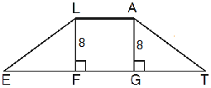

Since the altitude is a perpendicular segment, a right triangle is often formed. Using your knowledge of right triangles and properties of quadrilaterals, determine the missing side lengths in the figures below. (Hint: Often times you will need to use the Pythagorean Theorem or your knowledge of special right triangles! Also, remember the properties of a rectangle!)
1) In the diagram below, LATE is an isosceles trapezoid with , , , and . Altitudes and are drawn. What is the length of ?
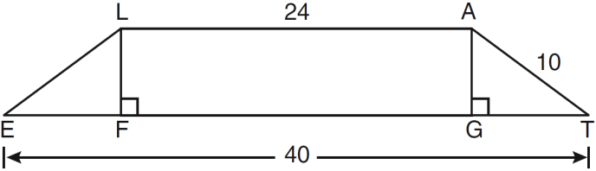

2) In the diagram below of isosceles trapezoid ABCD, , , and . What is the length of an altitude of the trapezoid?
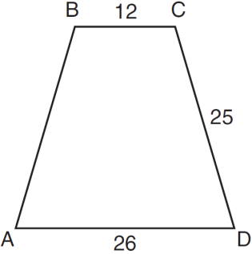

3) The cross section of an attic is in the shape of an isosceles trapezoid, as shown in the accompanying figure. If the height of the attic is 9 feet, feet, and feet, find the length of to the nearest foot.
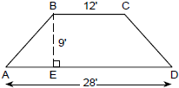

4) The accompanying diagram shows ramp leading to level platform , forming an angle of 45° with level ground. If platform measures 2 feet and is 6 feet above the ground, what is the length of?
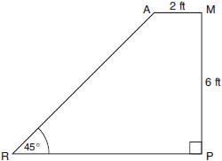
5) In isosceles trapezoid ABCD, . If , , and , what is the length of the altitude of the trapezoid?

6) If ABCD is an isosceles trapezoid and and CD = 12, what is the length of the altitude BE?
