Name:___________________________________ **Pythagorean Theorem**

Monica

Geometry Period:____

Date:______________________________

The Pythagorean Theorem is where *a, b*, and *c* are the side lengths in a right triangle (*a* and *b* are the legs and *c* is the hypotenuse). Any three whole numbers that satisfy are called **Pythagorean Triples.** Furthermore, any three numbers that satisfy make up the side lengths of a right triangle. So, far example, 3, 4, and 5 are a Pythagorean Triple (because they satisfy ) and, therefore, are the side lengths of a right triangle (since they satisfy ).

But what happens if three numbers do NOT satisfy ? What happens if or ? It turns out that this tells us information about the triangle as well!

**If, then the triangle is obtuse.**

**If , then the triangle is acute.**

Using this information, and your knowledge of Pythagorean theorem, answer the questions below.

1) Which set of numbers does *not* represent the sides of a right triangle? Does the set of numbers you selected create an acute or obtuse triangle? Explain.

|  |  |
| --- | --- |
| 1) |  |
| 2) |  |
| 3) |  |
| 4) |  |

2) The side lengths of a triangle are 8, 9, and 13. Classify this triangle as right, acute, or obtuse.

3) The set of integers  is a Pythagorean triple. Another such set is

|  |  |
| --- | --- |
| 1) |  |
| 2) |  |
| 3) |  |
| 4) |  |

4) Which set of numbers does *not* represent the sides of a right triangle?

|  |  |
| --- | --- |
| 1) |  |
| 2) |  |
| 3) |  |
| 4) |  |

5) In the diagram below of , , , and . What is the length of ?

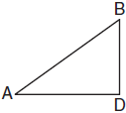

6) An overhead view of a revolving door is shown in the accompanying diagram. Each panel is 1.5 meters wide. What is the approximate width of *d*, the opening from *B* to *C*? Round your answer to the nearest hundredth.

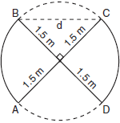

7) The diagram below shows a pennant in the shape of an isosceles triangle. The equal sides each measure 13, the altitude is **, and the base is 2*x*. What is the length of the base?

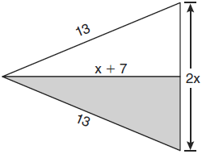

8) As shown in the diagram below, a kite needs a vertical and a horizontal support bar attached at opposite corners. The upper edges of the kite are 7 inches, the side edges are *x* inches, and the vertical support bar is  inches. What is the measure, in inches, of the vertical support bar?

