Name:______________________________________________ Review Outcome #3

1) Which illustration shows the correct construction of an angle bisector?
1) | 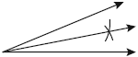 | 3) | 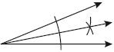
2) | 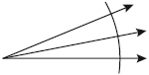 | 4) | 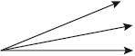

2) The diagram below shows the construction of the bisector of . Which statement is not true?

1) | 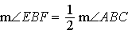 | 3)
2) | 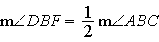 | 4)

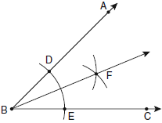

3) One step in a construction uses the endpoints of to create arcs with the same radii. The arcs intersect above and below the segment. What is the relationship of and the line connecting the points of intersection of these arcs?
1) | collinear
2) | congruent
3) | parallel
4) | perpendicular

4) The diagram below shows the construction of the perpendicular bisector of Which statement is not true?

1)
2) | 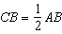
3)
4)

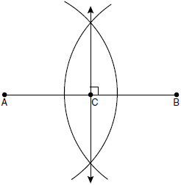

5) The diagram below illustrates the construction of parallel to through point P. Which statement justifies this construction?
1)
2)
3)
4)

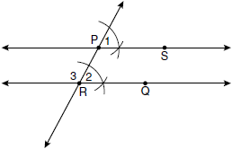

6) In the accompanying diagram of a construction, what does represent?
1) | an altitude drawn to
2) | a median drawn to
3) | the bisector of
4) | the perpendicular bisector of

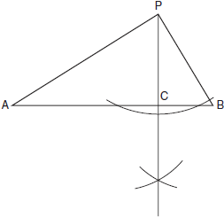

7) The diagram below shows the construction of a line through point P perpendicular to line m. Which statement is demonstrated by this construction?

1) | If a line is parallel to a line that is perpendicular to a third line, then the line is also perpendicular to the third line.
2) | The set of points equidistant from the endpoints of a line segment is the perpendicular bisector of the segment.
3) | Two lines are perpendicular if they are equidistant from a given point.
4) | Two lines are perpendicular if they intersect to form a vertical line.

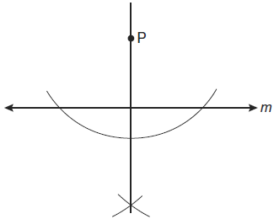

8) Using only a ruler and compass, construct the bisector of angle BAC in the accompanying diagram.

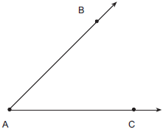

9) On the diagram of shown below, use a compass and straightedge to construct the perpendicular bisector of . [Leave all construction marks.]

10) Using a compass and straightedge, construct a line that passes through point P and is perpendicular to line m. [Leave all construction marks.]

11) Using a compass and straightedge, construct a line perpendicular to through point P. [Leave all construction marks.]

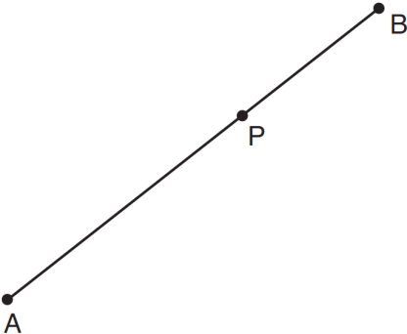

12) On the line segment below, use a compass and straightedge to construct equilateral triangle ABC. [Leave all construction marks.]

