Name:________________________________________ Saturday Regents Review

1) On the set of axes below, graph the locus of points that are four units from the point . On the same set of axes, graph the locus of points that are two units from the line . State the coordinates of all points that satisfy both conditions.
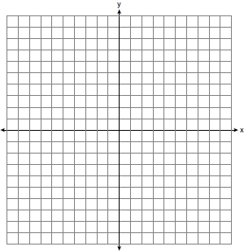
2) On the set of coordinate axes below, graph the locus of points that are equidistant from the lines and and also graph the locus of points that are 3 units from the y-axis. State the coordinates of all points that satisfy both conditions.
3) On the set of axes below, graph the locus of points that are 4 units from the line and the locus of points that are 5 units from the point . Label with an X all points that satisfy both conditions.

4) Given: bisects at E.
Prove:

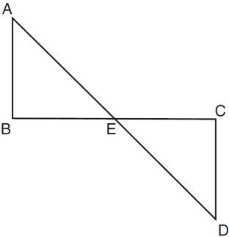

5) Given:JKLM is a parallelogram.
Prove: JKLM is a rhombus.
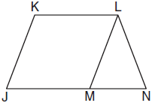

6) Given: and , C is the midpoint of and
Prove:
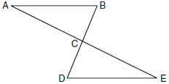

7) Given: parallelogram FLSH, diagonal , ,
Prove:
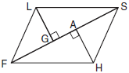

8) In the accompanying diagram of circle O, is a diameter with parallel to chord , chords and are drawn, and chords and intersect at E.
Prove:

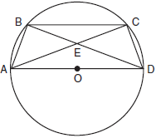

9) Given: with vertices , , and . has midpoint D, has midpoint E, and has midpoint F.
Prove: ADEF is a parallelogram
ADEF is not a rhombus
ADEF is not a trapezoid.
[The use of the grid is optional.]

10) In the accompanying diagram of circle O, chords and intersect at E. If , , , and , what is the value of x?
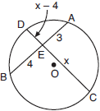

11) In the diagram below, is a tangent to circle O at point S, is a secant, , , and .
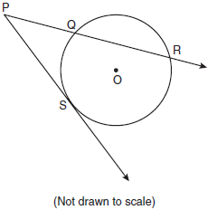

12) In the diagram below, is circumscribed about circle O and the sides of are tangent to the circle at points D, E, and F. If , , and , what is the length of ?
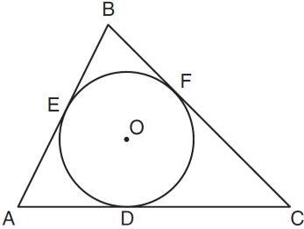

13) In the accompanying diagram of circle O, diameter is extended through B to external point P, tangent is drawn to point C on the circle, and . Find .
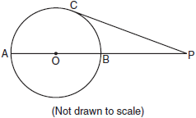

14) In the diagram below, quadrilateral STAR is a rhombus with diagonals and intersecting at E. , , , , , , and . Find SR, RT, and .
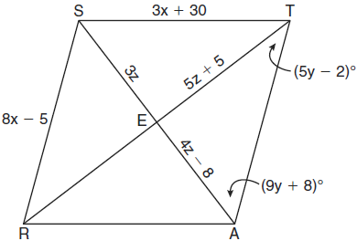

15) Given:, ,
Prove: is an isosceles right triangle.
[The use of the grid is optional.]

16) The angles of triangle ABC are in the ratio of . What is the measure of the smallest angle?

17) In the diagram below of , is extended to D. If , , and , what is the value of x?
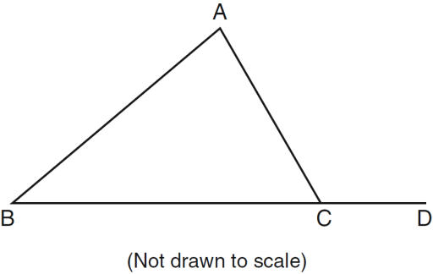

18) On the set of axes below, solve the following system of equations graphically and state the coordinates of all points in the solution.
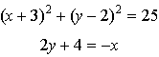
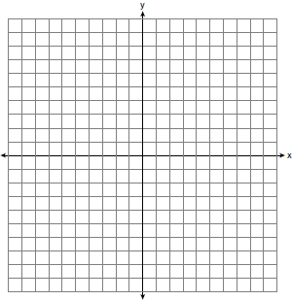

19) On the set of axes below, solve the system of equations graphically and state the coordinates of all points in the solution.
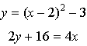

20) Determine the distance between point and point . Write an equation of the perpendicular bisector of . [The use of the accompanying grid is optional.]

