Name:__________________________________ Unit 10 – Working with Planes
Monica
Geometry Period:____
Date:____________________________

Directions: Some of the properties of planes are written as conditionals. That is, they are “if-then” statements. Your task is to find the converse, inverse, and contrapositive of each of these statements and determine their truth value. Remember, in order to prove a statement false you only need to find one counterexample!
#2: If two planes are perpendicular to the same line, they are parallel.
Converse: | Inverse: | Contrapositive:
Truth Value: | Truth Value: | Truth Value:
#4: If two lines are perpendicular to the same plane, then the lines are coplanar.
Converse: | Inverse: | Contrapositive:
#5: If a line is perpendicular to a plane, then every plane containing the line is perpendicular to the given plane.
Converse: | Inverse: | Contrapositive:
Truth Value: | Truth Value: | Truth Value:
Answer the multiple choice Regents questions below.

1) Point P is on line m. What is the total number of planes that are perpendicular to line m and pass through point P?

1) 1 2) 2 3) 0 4) infinite

2) Through a given point, P, on a plane, how many lines can be drawn that are perpendicular to that plane?

1) 1 2) 2 3) more than 2 4) none

3) If two different lines are perpendicular to the same plane, they are

1) collinear 2) coplanar 3) congruent 4) consecutive

4) If is contained in plane P, and is perpendicular to plane R, which statement is true?
1) | is parallel to plane R.
2) | Plane P is parallel to plane R.
3) | is perpendicular to plane P.
4) | Plane P is perpendicular to plane R.

5) In the diagram below, line k is perpendicular to plane P at point T. Which statement is true?

1) | Any point in plane P also will be  on line k. | 3) | All planes that intersect plane P  will pass through T.
2) | Only one line in plane P will  intersect line k. | 4) | Any plane containing line k is perpendicular to plane P.
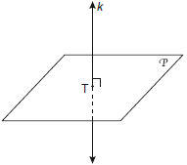
6) In the diagram below, is perpendicular to plane AEFG. Which plane must be perpendicular to plane AEFG
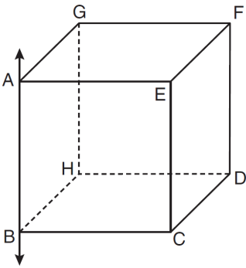
1) ABCE

2) BCDH

3) CDFE

4) HDFG

7) In three-dimensional space, two planes are parallel and a third plane intersects both of the parallel planes. The intersection of the planes is a

1) plane 2) point 3) pair of parallel lines 4) pair of intersecting lines

8) Line k is drawn so that it is perpendicular to two distinct planes, P and R. What must be true about planes P and R?
1) | Planes P and R are skew.
2) | Planes P and R are parallel.
3) | Planes P and R are perpendicular.
4) | Plane P intersects plane R but is not perpendicular to plane R.

