Name:_____________________________________ Unit 10 – Practice with Planes
Monica
Geometry Period:_____
Date:__________________________

Directions: Match each of the scenarios below the picture that best describes it.

# | Scenario |  |  | Picture
___ | If two planes are perpendicular to the same line, they are parallel. |  | #1
___ | Two planes are perpendicular to each other if and only if one plane contains a line perpendicular to the second plane. |  | #2
___ | If a line is perpendicular to a plane, then any line perpendicular to the given line at its point of intersection with the given plane is in the given plane. |  | #3 | 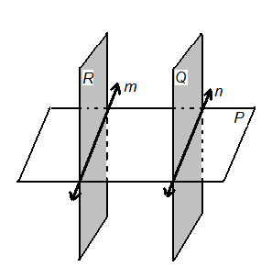
___ | If a plane intersects two parallel planes,  then the intersection is two parallel lines. |  | #4
Answer the multiple choice Regents questions below.

1) Point A is not contained in plane B. How many lines can be drawn through point A that will be perpendicular to plane B?
- One 2) Two 3) Zero 4) Infinite

2) If two different lines are perpendicular to the same plane, they are
- Collinear 2) coplanar 3) congruent 4) consecutive

3) Plane R is perpendicular to line k and plane D is perpendicular to line k. Which statement is correct?
1) Plane R is perpendicular to plane D.
2) Plane R is parallel to plane D.
3) Plane R is perpendicular to plane D.
4) Plane R bisects plane D.

4) As shown in the diagram below, is contained in plane R, and are contained in plane S, and , , and intersect at A. Which fact is not sufficient to show that planes R and S are perpendicular?
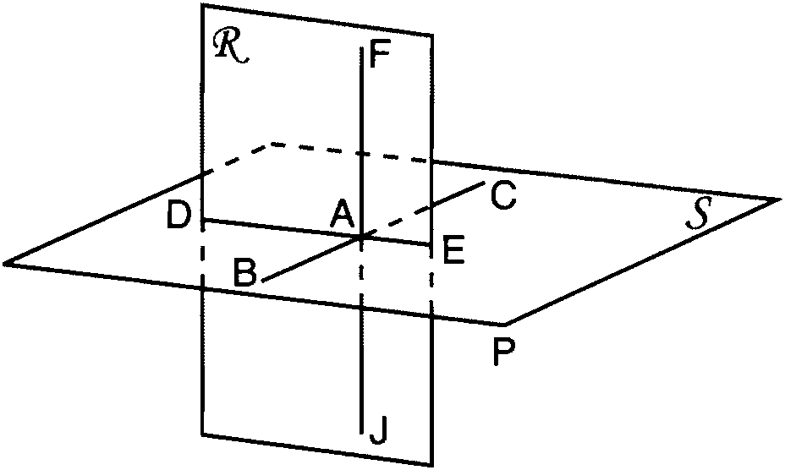
1)
2)
3)
4)

5) As shown in the diagram below, intersects planes P, Q, and R. If is perpendicular to planes P and R, which statement must be true?
1) | Plane P is perpendicular to plane Q.
2) | Plane R is perpendicular to plane P.
3) | Plane P is parallel to plane Q.
4) | Plane R is parallel to plane P.

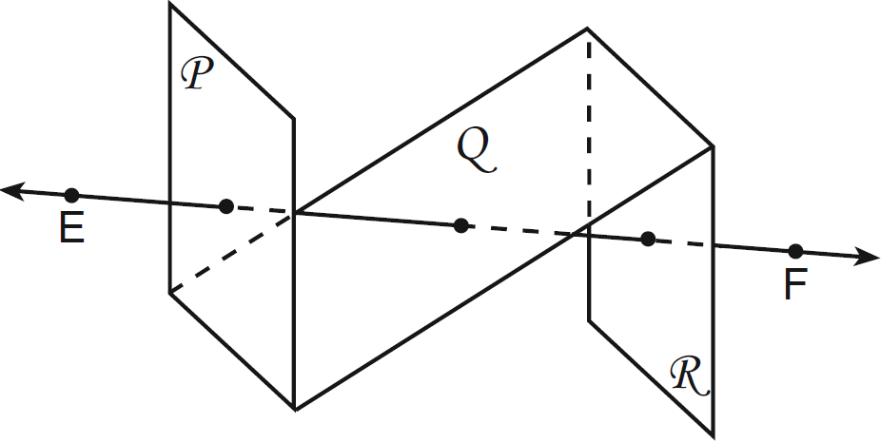

6) Line k is drawn so that it is perpendicular to two distinct planes, P and R. What must be true about planes P and R?
1) | Planes P and R are skew.
2) | Planes P and R are parallel.
3) | Planes P and R are perpendicular.
4) | Plane P intersects plane R but is not perpendicular to plane R.

7) If two distinct planes, A and B, are perpendicular to line c, then which statement is true?
1) | Planes A and B are parallel to each other.
2) | Planes A and B are perpendicular to each other.
3) | The intersection of planes A and B is a line parallel to line c.
4) | The intersection of planes A and B is a line perpendicular to line c.

8) A support beam between the floor and ceiling of a house forms a 90° angle with the floor. The builder wants to make sure that the floor and ceiling are parallel. Which angle should the support beam form with the ceiling?
1) 45° 2) 60° 3) 90° 4) 180°

