If a line is perpendicular to each of two intersecting lines at their point of intersection, then the line is perpendicular to the plane determined by them. |  | 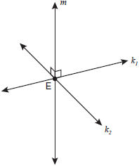
Two planes are perpendicular to each other if and only if one plane contains a line perpendicular to the second plane.
If a line is perpendicular to a plane, then any line perpendicular to the given line at its point of intersection with the given plane is in the given plane.
If two planes are perpendicular to the same line, they are parallel.

Through a given point there passes one and only one line perpendicular to a given plane. |  | 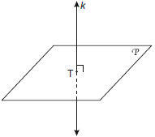
If a plane intersects two parallel planes,  then the intersection is two parallel lines. |  | 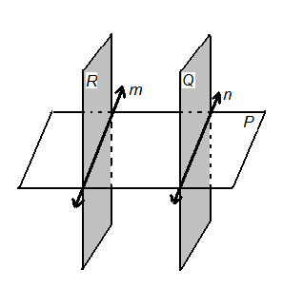
The intersection of two planes is a line. |  | 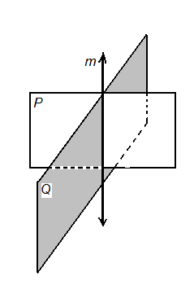
If two lines are perpendicular to  the same plane, then  the lines are coplanar. |  | 