Unit 10 Review
Do not write on me!!!

Directions: Answer all of the Regents multiple choice questions below. Record your answers on a separate sheet of paper. We will review as a class at the end of the period. Note: Only the last question is not a multiple choice question!

1) Point A lies in plane B. How many lines can be drawn perpendicular to plane B through point A?
1) one 2) two 3) zero 4) infinite

2) If two different lines are perpendicular to the same plane, they are

1) collinear 2) coplanar 3) congruent 4) consecutive

3) If is contained in plane P, and is perpendicular to plane R, which statement is true?
1) | is parallel to plane R.
2) | Plane P is parallel to plane R.
3) | is perpendicular to plane P.
4) | Plane P is perpendicular to plane R.

4) In the diagram below, line k is perpendicular to plane P at point T. Which statement is true?
1) | Any point in plane P also will be on line k. | 3) | All planes that intersect plane P will pass through T.
2) | Only one line in plane P will intersect line k. | 4) | Any plane containing line k is perpendicular to plane P.

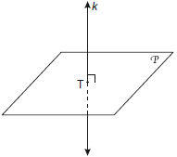

5) In three-dimensional space, two planes are parallel and a third plane intersects both of the parallel planes. The intersection of the planes is a
1) | plane | 3) | pair of parallel lines
2) | point | 4) | pair of intersecting lines

6) If two distinct planes, A and B, are perpendicular to line c, then which statement is true?
1) | Planes A and B are parallel to each other.
2) | Planes A and B are perpendicular to each other.
3) | The intersection of planes A and B is a line parallel to line c.
4) | The intersection of planes A and B is a line perpendicular to line c.

7) Point P lies on line m. Point P is also included in distinct planes Q, R, S, and T. At most, how many of these planes could be perpendicular to line m?

1) 1 2) 2 3) 3 4) 4

8) The figure in the diagram below is a triangular prism. Which statement must be true?
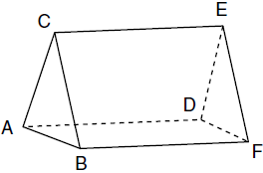
1)
2)
3)
4)

9) The diagram below shows a rectangular prism. Which pair of edges are segments of lines that are coplanar?
1) | and
2) | and
3) | and
4) | and

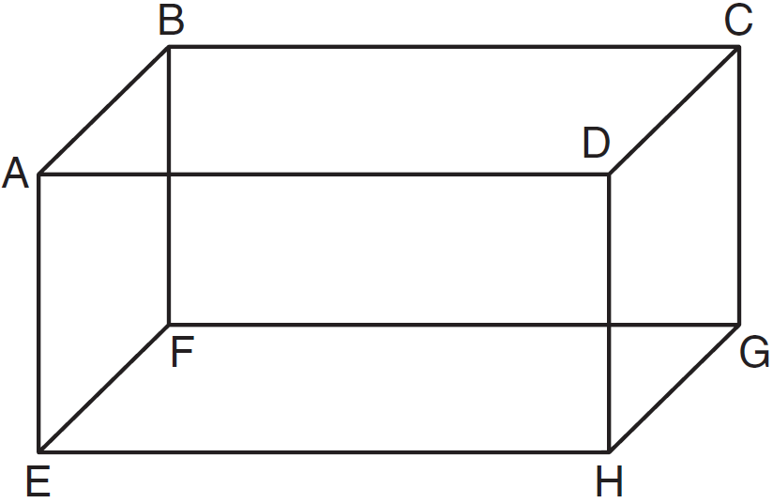

10) The diagram below shows a right pentagonal prism. Which statement is always true?
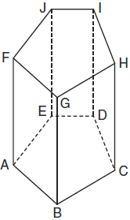
1)
2)
3)
4)

11) The diagram below represents a rectangular solid. Which statement must be true?
1) | and are coplanar
2) | and are coplanar
3) | and are skew
4) | and are skew

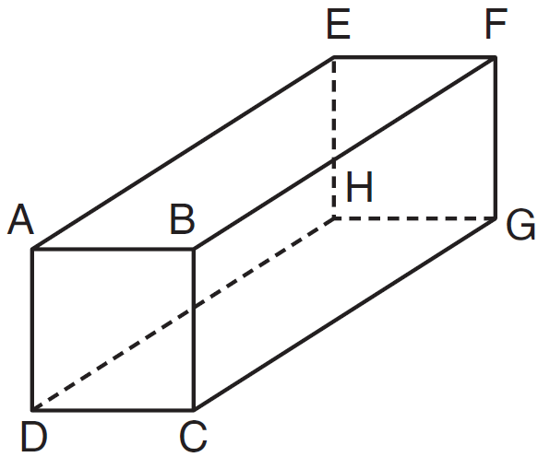

12) What is the negation of the statement “Squares are parallelograms”?
1) | Parallelograms are squares.
2) | Parallelograms are not squares.
3) | It is not the case that squares are parallelograms.
4) | It is not the case that parallelograms are squares.

13) Which statement is the negation of “Two is a prime number” and what is the truth value of the negation?
1) | Two is not a prime number; false
2) | Two is not a prime number; true
3) | A prime number is two; false
4) | A prime number is two; true

14) The statement is true when a is equal to

1) 10 2) 2 3) 3 4) 5

15) The statement "x is divisible by 5 or x is divisible by 4" is false when x equals

1) 10 2) 16 3) 20 4) 27

16) The statement “If x is divisible by 8, then it is divisible by 6” is false if x equals

1) 6 2) 14 3) 32 4) 48

17) Given the statement: “If two lines are cut by a transversal so that the corresponding angles are congruent, then the lines are parallel.” What is true about the statement and its converse?
1) | The statement and its converse are both true.
2) | The statement and its converse are both false.
3) | The statement is true, but its converse is false.
4) | The statement is false, but its converse is true.

18) Which compound statement is true?
1) | A triangle has three sides and a quadrilateral has five sides.
2) | A triangle has three sides if and only if a quadrilateral has five sides.
3) | If a triangle has three sides, then a quadrilateral has five sides.
4) | A triangle has three sides or a quadrilateral has five sides.

19) If , which statement is false?
1) | x is prime and x is odd.
2) | x is odd or x is even.
3) | x is not prime and x is odd.
4) | x is odd and 2x is even.

20) What is the inverse of the statement “If Julie works hard, then she succeeds”?
1) | If Julie succeeds, then she works hard.
2) | If Julie does not succeed, then she does not work hard.
3) | If Julie works hard, then she does not succeed.
4) | If Julie does not work hard, then she does not succeed.

21) Which statement is the converse of “If the sum of two angles is 180°, then the angles are supplementary”?
1) | If two angles are supplementary, then their sum is 180°.
2) | If the sum of two angles is not 180°, then the angles are not supplementary.
3) | If two angles are not supplementary, then their sum is not 180°.
4) | If the sum of two angles is not 180°, then the angles are supplementary.

22) Given the true statement: “If a person is eligible to vote, then that person is a citizen.” Which statement must also be true?
1) | Kayla is not a citizen; therefore, she is not eligible to vote.
2) | Juan is a citizen; therefore, he is eligible to vote.
3) | Marie is not eligible to vote; therefore, she is not a citizen.
4) | Morgan has never voted; therefore, he is not a citizen.

23) Which statement is logically equivalent to “If it is Saturday, then I am not in school”?
1) | If I am not in school, then it is Saturday.
2) | If it is not Saturday, then I am in school.
3) | If I am in school, then it is not Saturday.
4) | If it is Saturday, then I am in school.

24) A straw is placed into a rectangular box that is 3 inches by 4 inches by 8 inches, as shown in the accompanying diagram. If the straw fits exactly into the box diagonally from the bottom left front corner to the top right back corner, how long is the straw, to the nearest tenth of an inch? COMPLETE THIS QUESTION ON LOOSELEAF AND TURN IN TO MONICA.

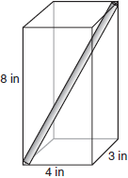

ANSWERS

- 1
- 2
- 4
- 4
- 3
- 1
- 1
- 3
- 3
- 4
- 1
- 3
- 1
- 3
- 4
- 3
- 1
- 4
- 3
- 4
- 1
- 1
- 3

