Name:___________________________________ Unit 5 – Quadrilateral Midpoint Investigation
Monica
Geometry Period:___
Date:__________________________________

Outcomes | Rating
#01: Argues with different types of reasoning in order to prove or disprove a statement | NY MS ES
#04: Be precise in calculating and applying the length and midpoint of a segment | NY MS ES
#06: Graphically and algebraically discerns if lines are parallel or perpendicular on a coordinate plane and can identify the point of intersection of intersecting lines | NY MS ES
#10: Discerns and applies theorems and relationships about quadrilaterals  and communicates those relationships | NY MS ES

DIRECTIONS: All work must be shown in order to receive a MS rating. Staple your work to the back of this sheet (or show all necessary work on the back).

Step 1: On the coordinate plane below, plot four random points: A, B, C, and D. Identify the coordinates in the spaces provided below.
A:_________ B: _________ C: _________ D: _________
Step 2: Connect the points to make quadrilateral. Determine the midpoints of the sides AB, BC, CD, and AD. Label these points J, K, L, and M, respectively. Identify the coordinates in the spaces provided below.
J: _________ K: _________ L: _________ M: _________
Step 3: What kind of quadrilateral is JKLM? Use the most precise name possible. Explain how you know this is true, using specific mathematical information to support your claim.
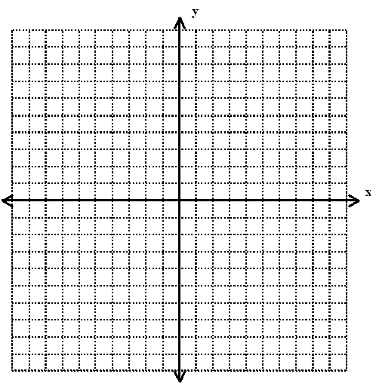
Step 4 (ES): Considering what you discovered in step 3, will this be true for EVERY quadrilateral? Prove it! (Hint: Do a coordinate proof, using the given information below.)
