Name:___________________________________ **Unit 5 – Deriving the Distance Formula**

Monica

Geometry Period:____

Date:____________________________________

**Directions:** For each of the questions below:

1. Identify the coordinates of points A, B, and C
2. Determine the lengths of AB and AC
3. Use the Pythagorean Theorem to determine the length of BC (If necessary, write your answer in simplest radical form.)

1)

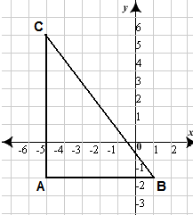

Coordinates of A:__________ Length of AB = ______________

Coordinates of B:__________ Length of AC = ______________

Coordinates of C:__________ Length of CB = ______________

2)

Coordinates of A:__________ Length of AB = ______________

Coordinates of B:__________ Length of AC = ______________

Coordinates of C:__________ Length of CB = ______________

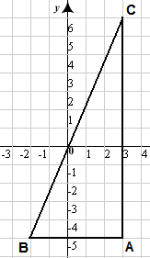

3)

Coordinates of A:__________ Length of AB = ______________

Coordinates of B:__________ Length of AC = ______________

Coordinates of C:__________ Length of CB = ______________

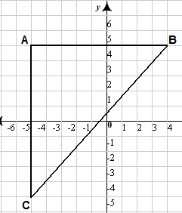

4) Look back at the coordinates for questions 1 – 3. Were any of the x-coordinates the same? Were any of the y-coordinates the same? Why did this happen?

5) The diagram below represents all of the questions you just answered. (Don’t believe me? Look back at your answer for question #4.) Determine the length of CB the same way you did for questions 1 – 3.

Coordinates of A:__________ Length of AB = _________________________

Coordinates of B:__________ Length of AC = _________________________

Coordinates of C:__________ Length of CB = _________________________

**C** 

**A**

**B** 