Name:____________________________________________ Unit 5 Review Part 1
Monica
Geometry Period:______ Date:_______________________________

Outcome | Question #s
#01: Argues with different types of reasoning in order to prove or disprove a statement | 17
#04: Be precise in calculating and applying the length and midpoint of a segment | 15, 16
#06: Graphically and algebraically discerns if lines are parallel or perpendicular on a coordinate plane and can identify the point of intersection of intersecting lines | 7, 8, 14
#07: Identifies polygons precisely and can determine angle sums and missing angle measures | 10 – 13
#08: Concludes if two triangles are congruent and identifies corresponding parts | 17
#10: Discerns and applies theorems and relationships about quadrilaterals  and communicates those relationships | 1 – 9, 14, 16

1) Determine if the following statements are true or false.

- _____ The diagonals of a parallelogram bisect the angles.
- _____ Consecutive angles in a parallelogram are complementary.
- _____ The diagonals of a kite are perpendicular.
- _____ The diagonals in a square are congruent.
- _____ All squares are rectangles.
- _____ Opposite angles in a parallelogram are congruent.
- _____ The diagonals of a parallelogram bisect each other.
2) Determine the length of MN in the trapezoid below.

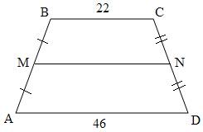

3) Determine the length of AB in the parallelogram below.

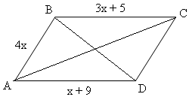

4) Determine the value of y in the rhombus below.
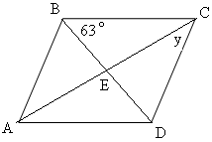

5) Determine the length of AD in the trapezoid below.
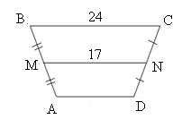

7) The slope of side AB in rectangle ABCD is . What is the slope of side AD? Why?

8) The slope of side KL in square JKLM is 0. What is the slope of side LM? Why?

9) Match each definition to the appropriate quadrilateral. (There are more words than definitions!)

_____1. A parallelogram with four right angles | a. Quadrilateral
 | b. Parallelogram
_____2. A quadrilateral with both pairs of opposite sides parallel | c. Rhombus
 | d. Rectangle
_____3. A quadrilateral with two pairs of adjacent sides congruent and no opposite sides congruent | e. Square
 | f. Kite
_____4. A parallelogram with four congruent sides | g. Trapezoid
 | h. Isosceles Trapezoid

10) The measure of one interior angle in a regular polygon is 160°. How many sides does this polygon have?

11) What is the sum of the interior angles in a regular decagon?

12) What is the measure of one exterior angle in a regular pentagon?

13) Find the value of x in the diagram below.
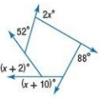

14)

15) What is the length of a segment with endpoints (-4, 5) and (6 -3)? Write your answer in simplest radical form.

16) Trapezoid ABCD is shown on the coordinate plane below. Prove that trapezoid ABCD is isosceles.
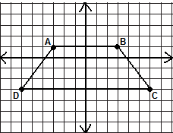

17) Given: ABCD is a parallelogram
Prove:

