Name:__________________________________________ Unit 5 Review Part 2
Monica
Geometry Period:____
Date:_____________________________________

Outcome | Question #s
#01: Argues with different types of reasoning in order to prove or disprove a statement | 2
#04: Be precise in calculating and applying the length and midpoint of a segment | 4
#06: Graphically and algebraically discerns if lines are parallel or perpendicular on a coordinate plane and can identify the point of intersection of intersecting lines | 4
#07: Identifies polygons precisely and can determine angle sums and missing angle measures | 3, 7
#08: Concludes if two triangles are congruent and identifies corresponding parts | 2
#10: Discerns and applies theorems and relationships about quadrilaterals and communicates those relationships | 1, 2, 4, 5, 6

1) In the diagram below, quadrilateral STAR is a rhombus with diagonals and intersecting at E. , , , , , , and . Find SR, RT, and .
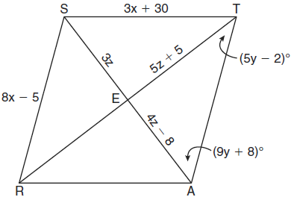

2) Given: ABCD is a rhombus
Prove:
E
D
C
B
A

3) The diagram below shows only part of a regular polygon. It is unknown how many sides the polygon has. If x + y = 312, how many sides must the polygon have?

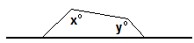

4) Quadrilateral ABCD has vertices A(1, 1), B(5, 2), C(6, -2), and D(2, -3). Use coordinate geometry to classify the quadrilateral using the most precise name possible. [Use of the grid is optional.]

5) Identify the statements below as true or false:

- ___________ The diagonals in a parallelogram are congruent.
b) ___________ The diagonals in a square bisect the angles.
c) ___________ A trapezoid has one pair of congruent sides.
d) ___________ The opposite angles in a rhombus are congruent.
e) ___________ The opposite sides in a rectangle are congruent.
f) ___________ The diagonals in an isosceles trapezoid are congruent.
g) ___________ All parallelograms are rectangles.
6) The measures of two consecutive angles are in the ratio of 3:7. What is the measure of the smaller angle?

7) What is the value of x in the hexagon below? (Note: Figure not drawn to scale.)
2x°
2x°
x+20°
102°
3x°
3x+15°

