Name:________________________________ Unit 6 – Compound Locus
Monica
Geometry Period:_____
Date:____________________________

Directions: Answer all of the questions below. Use dashed lines to indicate all loci. USE PENCIL!!! You may use a compass to help your draw the locus, where appropriate.

1) A man wants to place a new bird bath in his yard so that it is 30 feet from a fence, f, and also 10 feet from a light pole, P. As shown in the diagram below, the light pole is 35 feet away from the fence. Sketch all of the possible locations for the bird bath. Label the locations with an X.

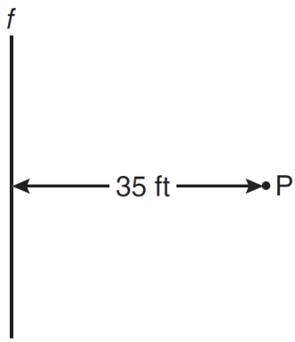

2) Towns A and B are 16 miles apart. How many points are 10 miles from town A and 12 miles from town B? Sketch a picture to support your claim.

3) Two lines, and , are parallel and 10 inches apart. Sketch the locus of all points that are equidistant from and and 7 inches from point R. Label with an X each point that satisfies both conditions.

4) In the diagram below, car A is parked 7 miles from car B. Sketch the points that are 4 miles from car A and sketch the points that are 4 miles from car B. Label with an X all points that satisfy both conditions.

5) In the diagram below, point M is located on . Sketch the locus of points that are 1 unit from and the locus of points 2 units from point M. Label with an X all points that satisfy both conditions.

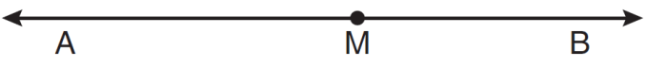

6) The length of is 3 inches. On the diagram below, sketch the points that are equidistant from A and B and sketch the points that are 2 inches from A. Label with an X all points that satisfy both conditions.

7) In the accompanying diagram, point P lies 3 centimeters from line . How many points are both 2 centimeters from line and 1 centimeter from point P? Sketch a picture to support your claim.

8) What is the total number of points equidistant from two intersecting straight roads and also 300 feet from the traffic light at the center of the intersection? Sketch a picture to support your claim

9) How many points are equidistant from two parallel lines and also equidistant from two points on one of the lines? Sketch a picture to support your claim.

10) Steve has a treasure map, represented in the accompanying diagram, that shows two trees 8 feet apart and a straight fence connecting them. The map states that treasure is buried 3 feet from the fence and equidistant from the two trees.
a Sketch a diagram to show all the places where the treasure could be buried. Clearly indicate in your diagram where the treasure could be buried.
b What is the distance between the treasure and one of the trees?

