Name:_____________________________________ Unit 6 – Locus on a Coordinate Plane
Monica
Geometry Period:_____
Date:_______________________________

Directions: Answer all of the questions below. Be sure to show all of your work. Use pencil!

1) In a coordinate plane, how many points are both 5 units from the origin and 2 units from the x-axis? Sketch a picture on one of the coordinate planes from your classwork handout.

- 1 b) 2 c) 3 d) 4

2) How many points are both 4 units from the origin and also 2 units from the line ? Sketch a picture on one of the coordinate planes from your classwork handout.

- 1 b) 2 c) 3 d) 4

3) In the coordinate plane, what is the total number of points 5 units from the origin and equidistant from both the x- and y-axes? Sketch a picture on one of the coordinate planes from your classwork handout.

a) 1 b) 2 c) 0 d) 4

4) The graph below shows the locus of points equidistant from the x-axis and y-axis. On the same set of axes, graph the locus of points 3 units from the line . Label with an X all points that satisfy both conditions.
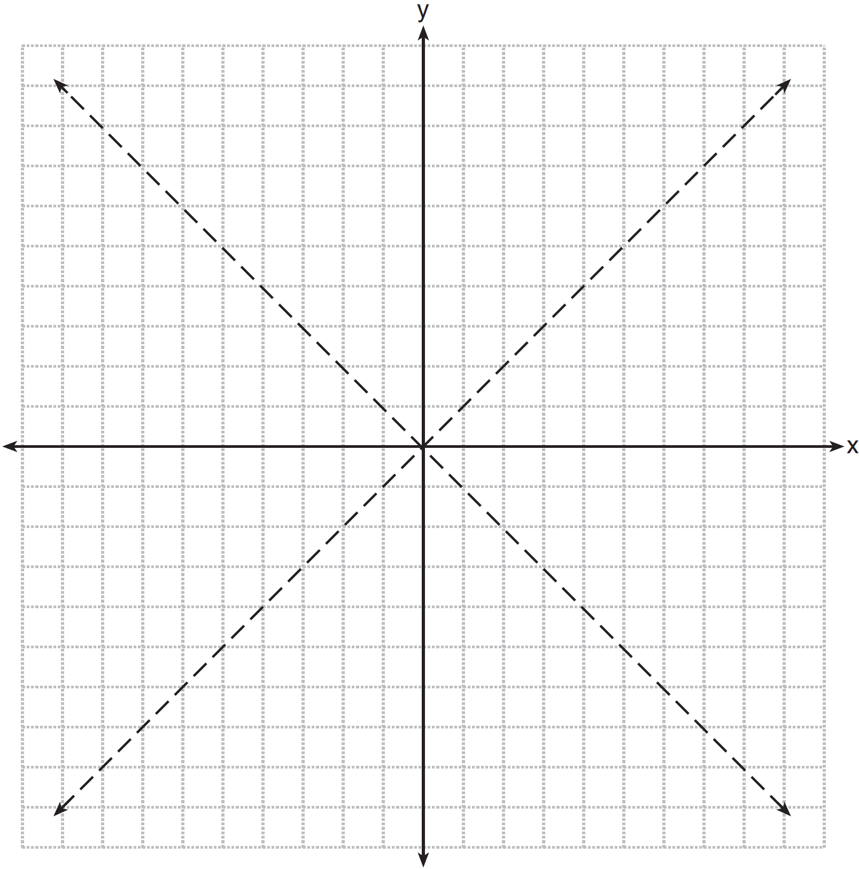

5) On the grid below, graph the points that are equidistant from both the x and y axes and the points that are 5 units from the origin. Label with an X all points that satisfy both conditions.

6) On the set of axes below, graph the locus of points that are four units from the point . On the same set of axes, graph the locus of points that are two units from the line . State the coordinates of all points that satisfy both conditions.

