Name:__________________________________________ **Unit 6 – Tangent Properties Investigation**

Monica

Geometry Period:____

Date:_______________________________

**Directions:** Today you will be using Geometer’s Sketchpad to explore the properties of tangents. Follow the directions below to make each sketch, and then answer the questions.

**STEP 1:** Use the circle tool to create circle A. Label the point on the circle B.

**STEP 2:** Construct radius AB.

**STEP 3:** Construct a tangent line to circle A. To do this, select point B and radius AB. Then, under the Construct menu, select “Perpendicular Line.”

**STEP 4:** Construct two points on the tangent. To do this, select the line and under the construct menu select “Point on Perpendicular Line.” Repeat this process to create the second point. Label these points C and D. (Note: Point C should be on the left side of B and point D should be on the right side of B.)

**STEP 5:** Measure and . To do this, select the three points in order and choose “angle” under the Measure menu. Record your findings below.

 

**QUESTION #1:** Drag point B around and observe how the measures of your angles change. Based on what you observe, complete the conjecture below:

* A tangent to a circle is ___________________________ to the radius drawn to the point of tangency.

**STEP 6:** On the same circle, construct a point on the circle. To do this, select the circle and choose “point on circle” under the Construct menu. Label this point E.

**STEP 7:** Repeat the process above to create another tangent line to circle A through point E.

**STEP 8:** Your new tangent line should intersect your old tangent line. Label this point of intersection F.

**STEP 9:** Measure the length of EF and BF. Record your findings below. To do this, select points E and F and choose “Distance” under the Measure menu.

 

**QUESTION #2:** Drag point B around and observe how the measures of your segments change. Based on what you observe, complete the conjecture below:

* Tangent segments to a circle from a point outside the circle are ___________________________.

**QUESTION #3:** What type of shape must ABFE be? Why? Explain.

**PART 2:** Using your new knowledge of tangents, answer the questions below. (Remember: Central angles are equal to the intercepted arc!) Show all work, including any calculations you perform (mentally or otherwise!).

1) 2)

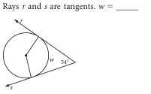

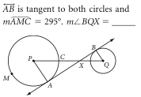

3)

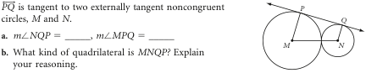

4)  are tangents.

1) If PA = 12, what is the length of PD? Explain how you know.

2) If , what is the measure of 

