Name:________________________________________  **Unit 6 – Properties of Chords**

Monica

Geometry Period:____

Date:_______________________________________

**Part 1 Directions:** Follow the steps below to explore the properties of chords. Remember the measure of a central angle is equal to its intercepted arc!

**STEP 1:**  Using a compass, construct a circle and label its center O in the space below. Use your compass to construct two congruent chords. Label the chords and . Construct radii , , , and .

**STEP 2:** Use a protractor to measure and . Record your results below.

 

**QUESTION #1:**  How do the measures of and compare? Compare the results with other members at your table. Then complete the conjecture below.

* If two chords in a circle are congruent, then they determine two central angles that are _____________________________.

**QUESTION #2:** We learned yesterday that a minor arc has the same measure as its central angle. If chords and  are congruent and central anglesand are congruent, what can you conclude about their intercepted arcs, *AB* and *CD*? Complete the conjecture below.

* If two chords in a circle are congruent, then their ______________________________________ are congruent.

**PROOF:** Let’s prove that our conjecture is true!

Given: Circle O

Radii OA, OB, OC, and OD



Prove:  (We’re proving the conjecture in question #1.)

D

C

B

O

A

**NOTE:** As we’ve discussed in previous units, the distance from a point to a line is the perpendicular segment. If the distance from the center of a circle to two chords is the same, then the chords must be congruent. The diagram below illustrates this. If , then . For an exceeding standards opportunity for outcome #1, prove this is true and submit it on looseleaf.

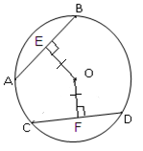

**STEP 3:** Go to tywlsgeometry.weebly.com and open the file “Intersecting Chord and Diameter.” This file can be found on the “Unit 6 – Circles” page (under Day 2).

**STEP 4:** Measure  Record the results below.



**QUESTION #3:** Considering this angle measure, what do you suppose the measures of , , and  will be? Why? Explain.

**STEP 5:**  Measure the length of CE, EO, AE, and EB. Record the results below.

CE = ____________ EO = ____________ AE = _____________ EB = ______________

**QUESTION #4:** Drag points E and D around to change the size of your circle and chord. Observe how your measurements change. Based on what you notice, complete the conjectures below:

* In a circle, a diameter that is perpendicular to a chord _______________ the chord.
* In a circle, a diameter that bisects a chord (that is not a diameter) is ________________________ to the chord.

**Part 2 Directions:** Using what you’ve learned in today’s investigation, answer the following questions.

1) Determine the value of x in the 2) Determine the value of x in the

diagram below. diagram below.

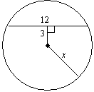

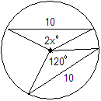

3) Determine the value of x in the diagram below.

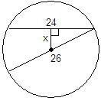

4) Determine the value of x in the diagram below.

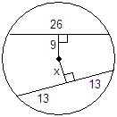

6) Determine the value of x in the diagram below.

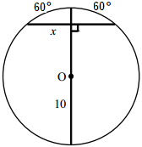

5) In the diagram below of circle *O*, radius  is 5 cm. Chord  is 8 cm and is perpendicular to  at point *P*.What is the length of , in centimeters?

