Name:__________________________________ Practice with Tangents, Chords, and Inscribed Angles
Monica
Geometry Period:_____
Date:___________________________

Directions: Answer all of the questions below. Questions with correct answers and no (or incorrect) work shown will not receive any credit.

- In the diagram below, circle O has a radius of 5, and . Diameter is perpendicular to chord at E. What is the length of ?
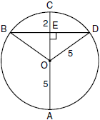
2) In the diagram below of circle O, diameter is perpendicular to chord at point E, , and . What is the length of ? Write your answer in simplest radical form.
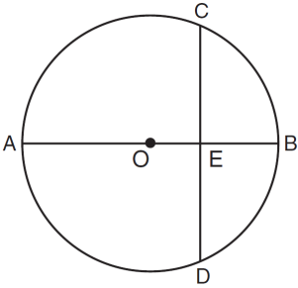
3) In the diagram below of circle O, diameter is perpendicular to chord at E. If and , find the length of .
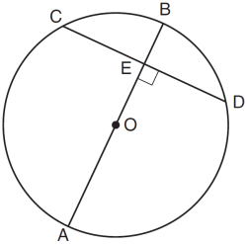
4) In the diagram of circle O below, chord is parallel to diameter and . What is ?
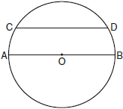

5) In the diagram below, two parallel lines intersect circle O at points A, B, C, and D, with and . Find .
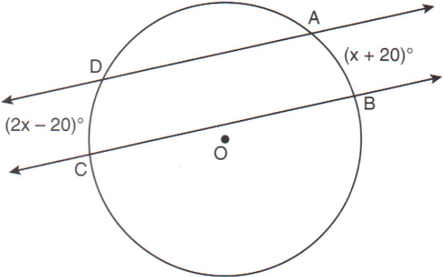
6) In the accompanying diagram, chord is parallel to diameter . If , what is ?
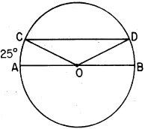
7) In the diagram below of , is tangent to circle O at point A, , and .What is the length of ?
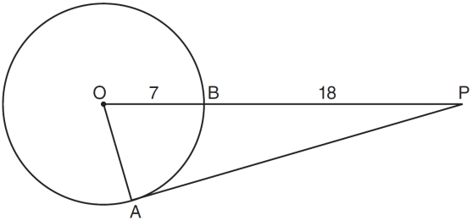

8) In the accompanying diagram, and are tangents drawn to circle O. If , find .
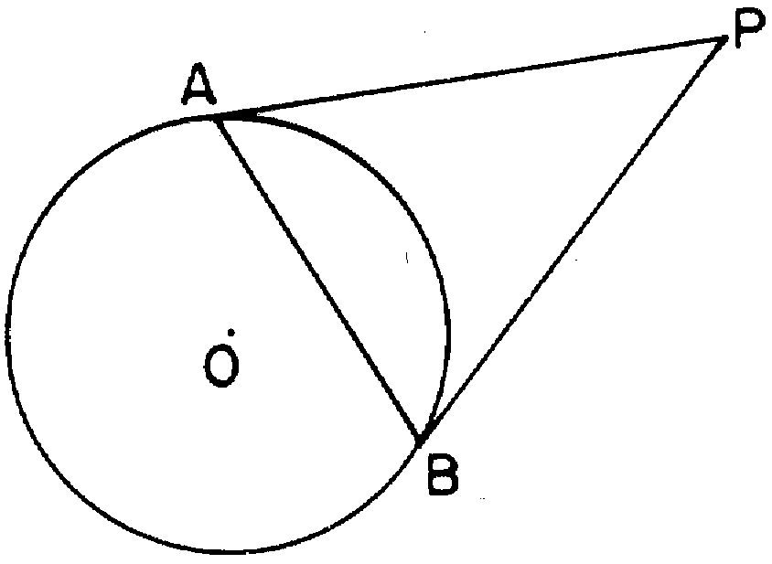

9) In the accompanying diagram, and are tangents drawn to circle O, and chord is drawn. If , what is ?
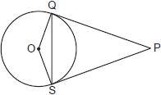
10) In the diagram below, circles X and Y have two tangents drawn to them from external point T. The points of tangency are C, A, S, and E. The ratio of TA to AC is . If , find the length of .
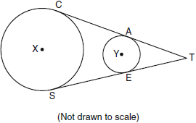

11) In the diagram below, KJ is tangent to circle M at point J. If KJ = 17, and LK = 10, what is the length of the radius of the circle?
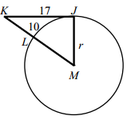

12) In the diagram below, circle O has . What is in terms of z?
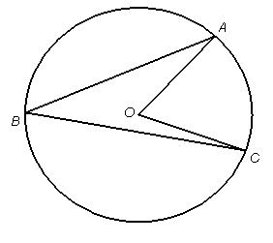
13) In the diagram below of circle O, chords , , , and are drawn such that . What is the ?
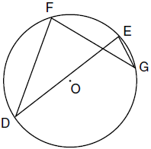

14) In the accompanying diagram, is a diameter and . Find .
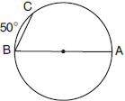
15) In the accompanying diagram of circle O, and . Find the value of x.
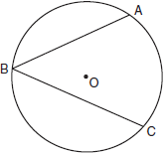

16) In the accompanying diagram, quadrilateral ABCD is inscribed in circle O. If and , find .
