Name:______________________________________ **Classwork – Unit 6**

Monica

Geometry Period:_____

Date:________________________________

**Directions:** Answer all of the questions below. Be sure to show all of your work!

1) Which set of numbers could be the lengths of the sides of a right triangle?

|  |  |
| --- | --- |
|  | 1)  2)  3)  4) |

2) Determine the value of x in the triangle below.

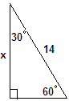

3) In the accompanying diagram of circle *O*, diameter  is perpendicular to chord  at *E*, , and . What is the length of the diameter of circle *O*?

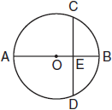

4) In the accompanying diagram,  and  are tangents to circle *O*, and chord  is drawn. If , what is ?

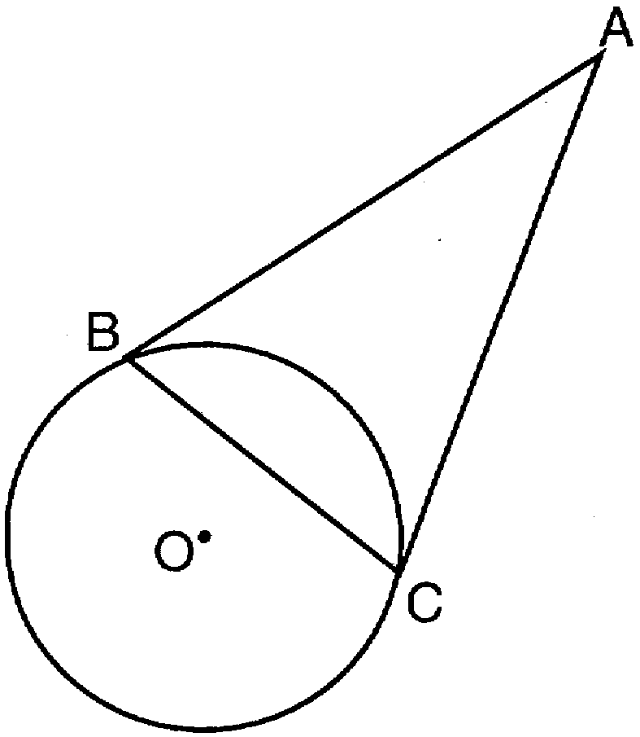

5) In the diagram below of circle *O*, chords  and  intersect at *E*, , and . What is the degree measure of ?

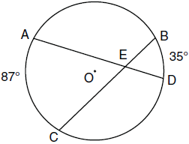

6) In the diagram below, chords  and  intersect at *E*. If , , and , what is the value of *x*?

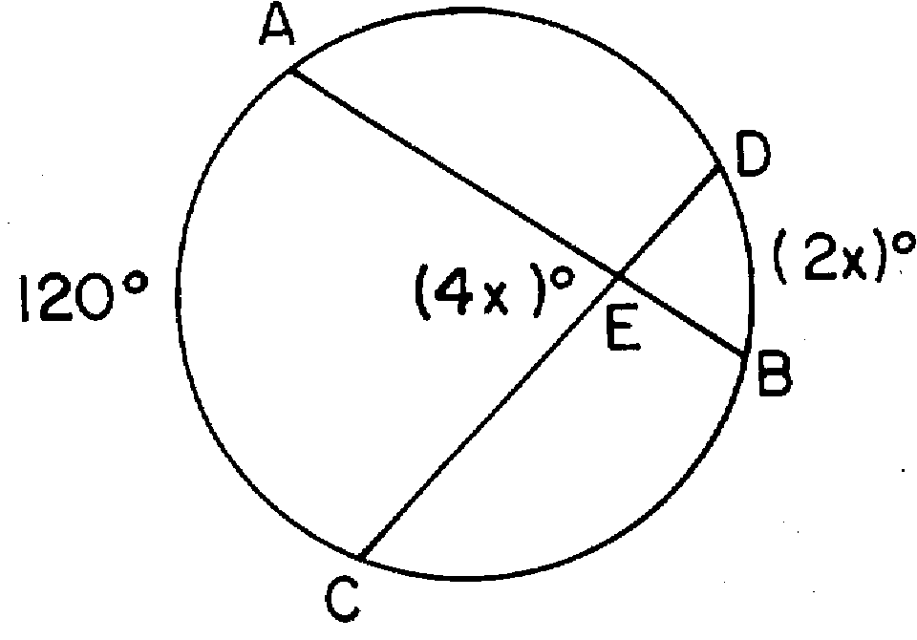

7) The new corporate logo created by the design engineers at Magic Motors is shown in the accompanying diagram. If chords  and  are congruent and , what is ?

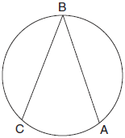

8) In the accompanying diagram of circle *O*, the measure of  is 64º. What is ?

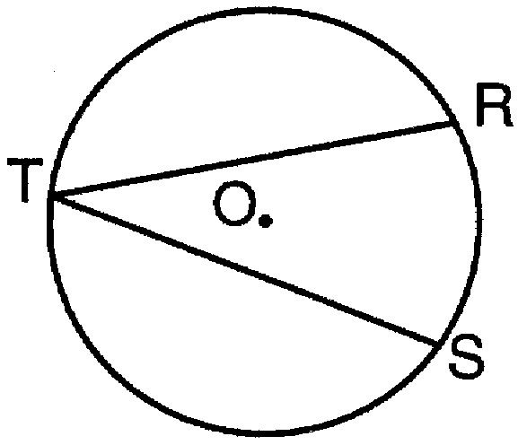

9) In the diagram below,  is tangent to circle *O*, and  is a chord. If *,* find the measure of **.

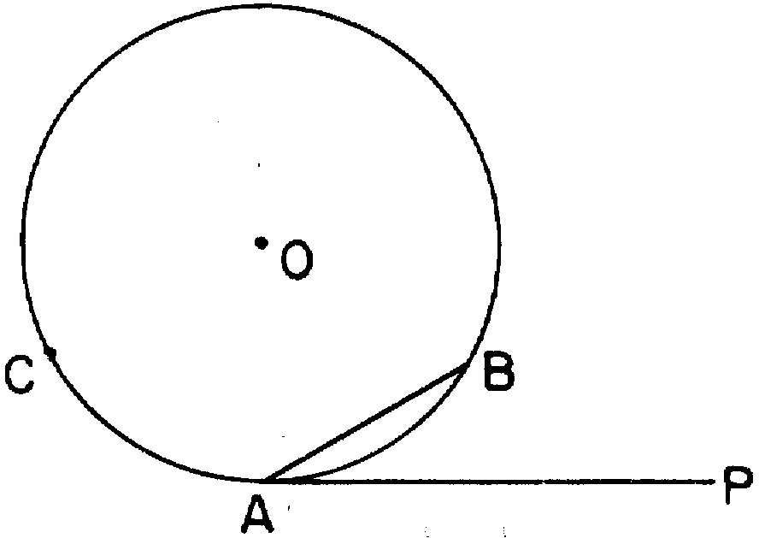

10) Given the circle below with two secants, determine the value of x.  
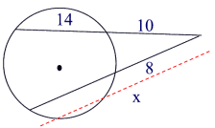

11) Given the circle with a tangent and a secant, determine the value of x. Write your answer in simplest radical form.

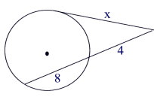

12) Given the circle below with two secants, determine the value of x.

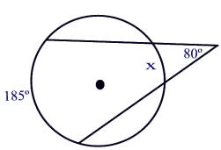

13) Given the circle below with two tangents, determine the value of x.

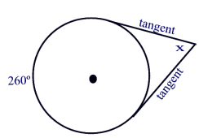

14) In the diagram below, the measure of arc BD is 50 degrees. Determine the measure of angles 1, 2, 3, 4, 5, and 6.

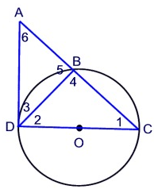

15) In the diagram below,  If the measure of arc BC is 100 degrees, what is the measure of 

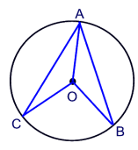

16) Given the circle below with two intersecting chords, determine the value of x.

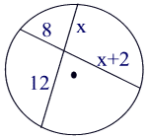

17) Three tangents are drawn to the circle below. Determine the value of x.

