Name:____________________________________ **Unit 6 – HW Handout #1**

Monica

Geometry Period:_____

Date:_______________________________

**Directions:** Answer all of the questions below. You must show all of your work in order to receive a “MS” rating!

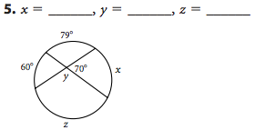

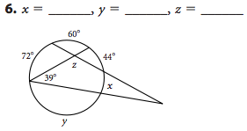

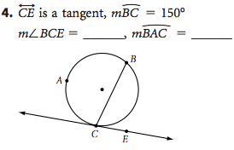

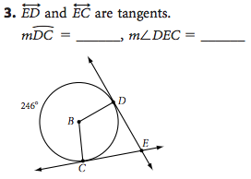

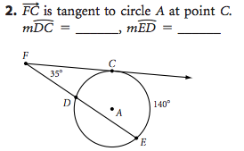

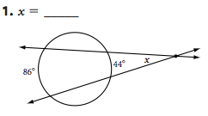

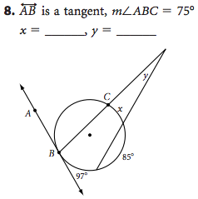

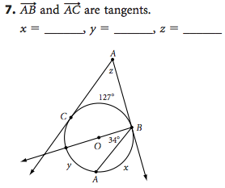

10)

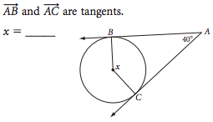

9)

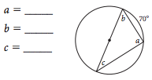

11) 