Name:__________________________________________ **Unit 6 Review**

Monica

Geometry Period:____

Date:___________________________________________

**Directions:** **The questions below are broken up by outcome. If there are certain questions you find yourself struggling with, be sure to spend extra time reviewing the material needed to receive a “MS” on that outcome. These questions are excellent practice for your upcoming test.**

***Outcome #6: Concludes if two triangles are congruent and identifies corresponding parts***

**1)** In the diagram below of  and ,  and  intersect at *E*, such that  and .

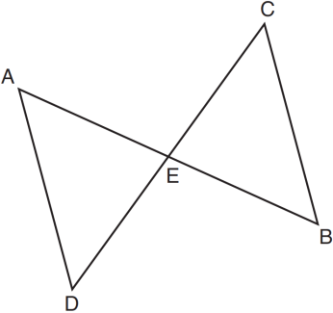

Triangle *DAE* can be proved congruent to triangle *BCE* by

|  |
| --- |
| 1) ASA 2) SAS 3) SSS 4) HL |

**2)** In the diagram of quadrilateral *ABCD*, , , and diagonal  is drawn.

Which method can be used to prove  is congruent to ?

|  |
| --- |
| 1) AAS 2) SSA 3) SAS 4) SSS |

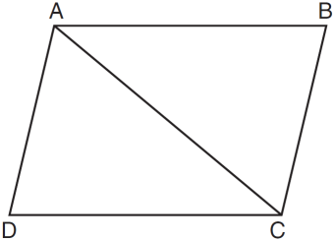

3) In the accompanying diagram, , , , , , and . Which statement would *not* be used to prove ?

|  |  |
| --- | --- |
| 1) |  |
| 2) |  |
| 3) |  |
| 4) |  |

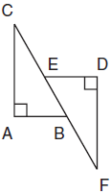

4) If , which of the following is not true?

1)  2)  3)  4) 

***Outcome #7: Discerns and applies theorems and relationships within triangles and communicates******those relationships***

**5)** Phil is cutting a triangular piece of tile. If the triangle is scalene, which set of numbers could represent the lengths of the sides?

|  |
| --- |
| 1)  2)  3)  4) |

**6)** In ,  feet and  feet. What are all of the possible values for ?

**7)** If two sides of a triangle are 1 and 3, the third side may be

|  |
| --- |
| 1) 5 2) 2 3) 3 4) 4 |

**8)** A plot of land is in the shape of rhombus *ABCD* as shown below. Which can *not* be the length of diagonal *AC*?

|  |
| --- |
| 1) 24 m 2) 18 m 3) 11m 4) 4 m |

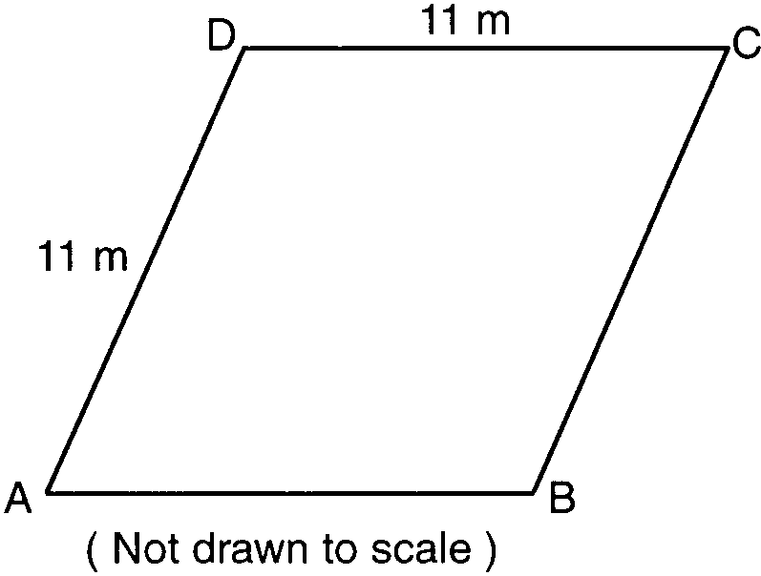

**9)** In , , , and . Which expression correctly relates the lengths of the sides of this triangle?

|  |
| --- |
| 1)  2)  3)  4) |

**10)** In , , , and . Which list has the angles of  in order from smallest to largest?

|  |
| --- |
| 1)  2)  3)  4) |

**11)** As shown in the diagram of  below, *B* is a point on  and  is drawn. If , , and , what is the longest side of ? Explain.

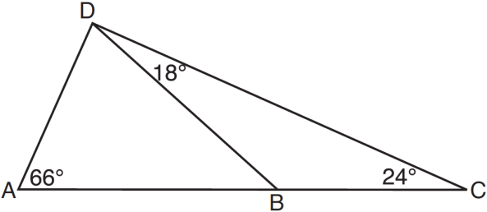

**12)** In the diagram of  below, , , and  is extended through *N*. What is the measure of ?

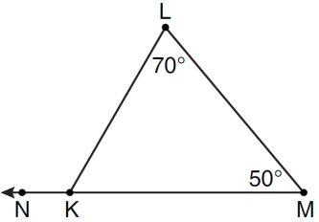

**13)** In the diagram below of , side  is extended to point *D*, , , and . What is ?

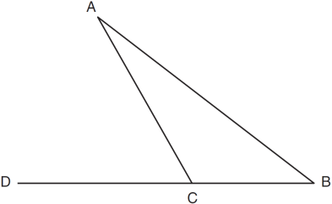

**14)** In the diagram below of , side  is extended to point *A*. Which statement must be true?

|  |  |
| --- | --- |
| 1) |  |
| 2) |  |
| 3) |  |
| 4) |  |

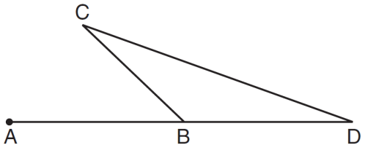

***Outcome #1: Argues with different types of reasoning in order to prove or disprove a statement***

**15)** Given:  bisects  at *E*.





Prove: 

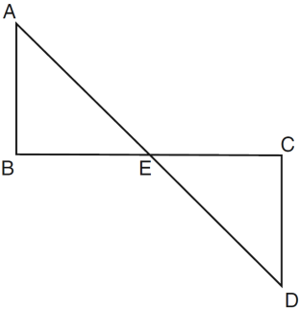

16)

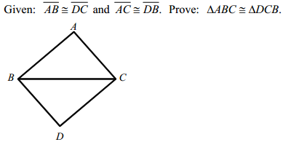

17)

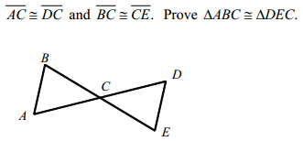



18)

