Name:_______________________________________ **Unit 6 – Review**

Monica

Geometry Period:_____

Date:__________________________________

1) In the diagram below of circle *O*, chords  and  intersect at *M*. Secant  and tangent  are drawn to circle *O*. The length of  is two more than the length of , , , and .

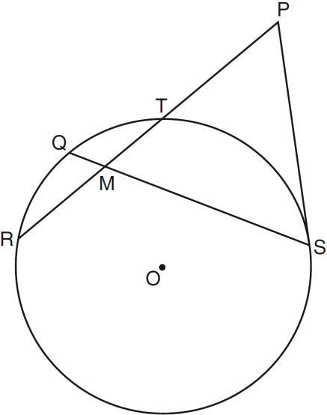

1. Find the length of .
2. Find the length of .

2) In the accompanying diagram of circle *O*, chords  and  intersect at *E* and . What is ?

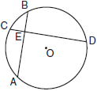

3) In the diagram below, quadrilateral *JUMP* is inscribed in a circle. Opposite angles *J* and *M* must be

|  |  |
| --- | --- |
| 1) | right |
| 2) | complementary |
| 3) | congruent |
| 4) | supplementary |

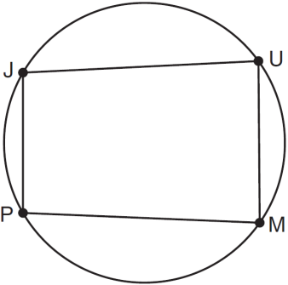

4) In circle *O*,  and  are tangent to the circle from point *P*. If the ratio of the measure of major arc *AB* to the measure of minor arc *AB* is , determine .

5)

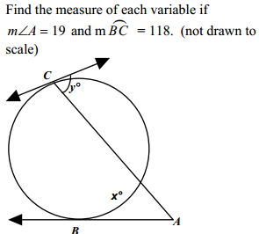

6) Write an equation of the circle whose diameter ** has endpoints ** and *.*

7) A triangular park is formed by the intersection of three streets, Bridge Street, Harbor Place, and College Avenue, as shown in the accompanying diagram. A walkway parallel to Harbor Place goes through the park. A time capsule has been buried in the park in a location that is equidistant from Bridge Street and College Avenue and 5 yards from the walkway. Indicate on the diagram with an **X** *each* possible location where the time capsule could be buried.

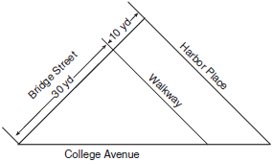

8) Given:

Circle O

Diameter AB

Secants and 

is the perpendicular bisector of 

the measure of arc AF is 110°



AO = 10

AC = 36

Find: the measure of arc BD

The length of CE

