Name:_________________________________________ **Unit 7 – Proving Triangles Similar using AA~**

Monica

Geometry Period:_____

Date:__________________________________________

**Directions:**  Each of the proofs below requires using the AA~ postulate. Complete each proof using this postulate.

1) Given: 

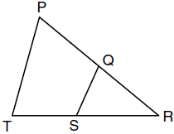

Prove: 

2) Given: 

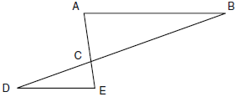

Prove: 

3) Given: ,  is tangent to circle O

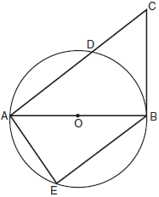

Prove: 



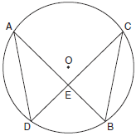

4) Given: Circle O with chords  and  drawn

Prove: 