Name:_________________________________________ **Unit 7 – Proportions in Triangles**

Monica

Geometry Period:_____

Date:_____________________________________

**Directions:** Today you will be using GSP to explore proportions in triangles. Be sure to follow the steps carefully and answer all of the questions.

**STEP 1:** Draw .

**STEP 2:** Construct point D on .

**STEP 3:** Construct line DE parallel to . (To do this, select point D and . Then choose “Parallel Line” under the “Construct” menu. Label the point of intersection E.)

**STEP 4:** Measure  (To do this, select the endpoints of each segment and choose “Distance” under the “Measure” menu.)

**STEP 5:** Calculate the ratios  (To do this, select “Calculate” under the “Measure” menu. Select the measurement for BD, then select the division symbol, then select the measurement for DA. Hit “OK”. Repeat this process for the other ratio.)

**QUESTION #1: What do you notice about these ratios?**

**STEP 6:** Drag point B to change the measurements of your segments. Observe how the ratios change.

**QUESTION #2: What do you notice about the ratios as you change point B? Why do you think this happens?**

**STEP 7:** Open a new sketch. (To do this, select “New Sketch” under “File”.)

**STEP 8:** Draw .

**STEP 9:** Construct the angle bisector of . (To do this, select points C, A, and B, in that order, and choose “Angle Bisector” under the “Construct” menu.)

**STEP 10:** Label the point of intersection of the angle bisector and  as point D.

**STEP 11:** Measure  (To do this, select the endpoints of each segment and choose “Distance” under the “Measure” menu.)

**STEP 12:** Calculate the ratios  (To do this, select “Calculate” under the “Measure” menu. Select the measurement for AC, then select the division symbol, then select the measurement for AB. Hit “OK”. Repeat this process for the other ratio.)

**QUESTION #3: What do you notice about these ratios?**

**STEP 13:** Drag points A, B, and C to change the measurements of your segments. Observe how the ratios change.

**QUESTION #4: What do you notice about the ratios as you change these points?**

**STEP 14:** Open a new sketch. (To do this, select “New Sketch” under “File”.)

**STEP 15:** Construct . (To do this, use your line tool to draw . Then use your point tool to draw point C below . Select point C and , then choose “Parallel Line” under the “Construct” menu.)

**STEP 16:** Construct lines . (To do this, select points A and C, and choose “Line” under the “Construct” menu. Repeat for points B and D.)

**STEP 17:** Construct point E on . (To do this, select  and choose “Point on Line” under the “Construct” menu.)

**STEP 18:** Construct . (To do this, select point E and . Choose “Parallel Line” under the “Construct” menu. Label the point of intersection F.)

**STEP 19:** Measure  (To do this, select the endpoints of each segment and choose “Distance” under the “Measure” menu.)

**STEP 20:** Calculate the ratios  (To do this, select “Calculate” under the “Measure” menu. Select the measurement for AC, then select the division symbol, then select the measurement for CE. Hit “OK”. Repeat this process for the other ratio.)

**STEP 21:** Drag points A, B, C, and E around to change the ratios.

**QUESTION #5: What do you notice about these ratios? How did the ratios change when you dragged the points around?**

**PART 2: Complete the conjectures below based on what you explored today.**

1. If a line is parallel to one side of a triangle and intersects that other two sides, then

______________________________________________________________________________________.

2. If a ray bisects an angle of a triangle, then __________________________________________________

______________________________________________________________________________________.

3. If three parallel lines intersect two transversals, then __________________________________________

_______________________________________________________________________________________.

**PART 3:** Apply what you’ve learned today to answer the questions below.

1) In the diagram below of , , , , and . What is the length of ?

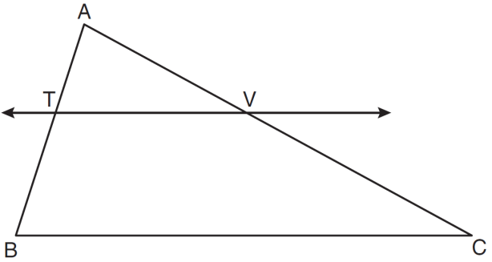

2) In the diagram below of , . If , , and , what is the length of ?

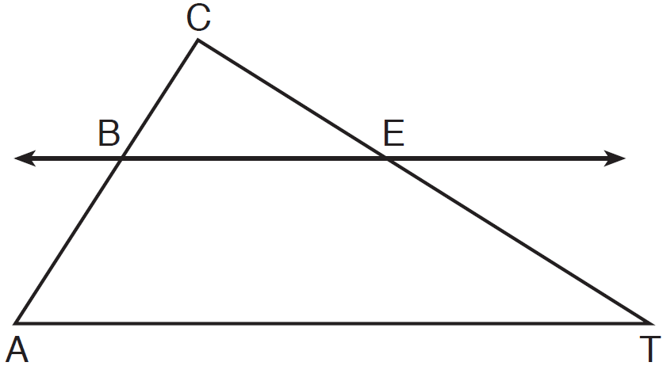

3) In the diagram below of , *B* is a point on  and *C* is a point on  such that , , , , and . Find the length of .

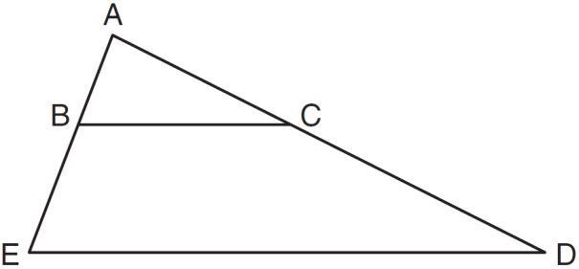

4) What is the length of AB in the triangle below? Round your answer to the nearest tenth.

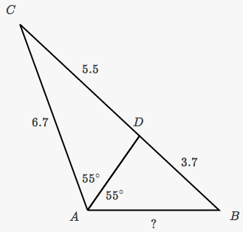

5) The three lines in the diagram below are parallel. Determine the value of x.

