Name:________________________________________ **Unit 7 – HW Handout #1**

Monica

Geometry Period:___

Date:_________________________________________

**Directions:** Answer all of the questions below. You must show your work (including the multiple choice questions) in order to receive a “MS” rating. Correct answer with no work shown or missing work will receive a “NY” rating.

1) A triangle has sides whose lengths are 5, 12, and 13. A similar triangle could have sides with lengths of

|  |  |
| --- | --- |
| 1) | 3, 4, and 5 |
| 2) | 6, 8, and 10 |
| 3) | 7, 24, and 25 |
| 4) | 10, 24, and 26 |

2) The accompanying diagram shows two similar triangles. Which proportion could be used to solve for *x*?

|  |  |
| --- | --- |
| 1) |  |
| 2) |  |
| 3) |  |
| 4) |  |

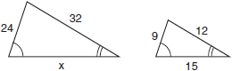

3) The Rivera family bought a new tent for camping. Their old tent had equal sides of 10 feet and a floor width of 15 feet, as shown in the accompanying diagram. If the new tent is similar in shape to the old tent and has equal sides of 16 feet, how wide is the floor of the new tent?

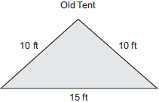

4) In the accompanying diagram, ~, RQ = 30, QS = 21, SR = 27, and LN = 7. What is the length of ?

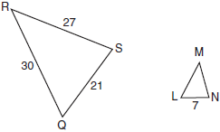

5) In the accompanying diagram, triangle *A* is similar to triangle *B*. Find the value of *n*.

