Name:________________________________________________ **Unit 7 – HW Handout #2**

Monica

Geometry Period:____

Date:_____________________________________________

**Directions:** Use a paragraph proof, two-column proof, or flow chart proof to prove the following statements are true.

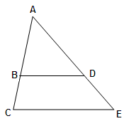

1. Given: 

Prove: 

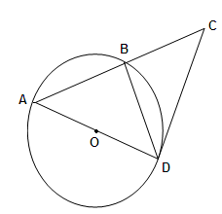

1. Given:  tangent to circle O

Diameter AD

B is the midpoint of arc AD

Prove: 