Name:________________________________________ Unit 7 HW Handout #3
Monica
Geometry Period:_____
Date:________________________________

Directions: Answer all of the questions below. Write your answers in simplest form whenever necessary. Be sure to show all of your work.

1) In the diagram below of , Q is a point on , S is a point on , is drawn, and .
Which reason justifies the conclusion that ?

1) | AA
2) | ASA
3) | SAS
4) | SSS
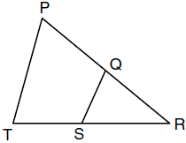

2) In the diagram of and below, and intersect at C, and . Which method can be used to show that must be similar to ?
1) | SAS
2) | AA
3) | SSS
4) | HL
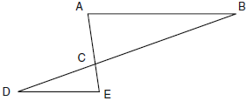

3) In and , 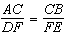. Which additional information would prove ?
1)
2)
3)
4)

4) In the accompanying diagram, and and intersect at point T. Prove that .

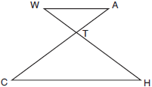

5) In the diagram below of , D is a point on , E is a point on , , inches, inches, and inches. Find, to the nearest tenth of an inch, the length of .

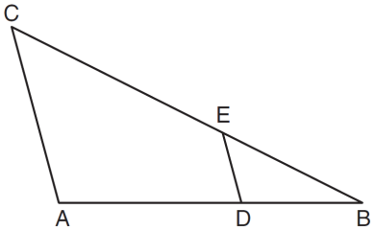
d

6) In the diagram below of right triangle ABC, is the altitude to hypotenuse , , and . What is the length of ?

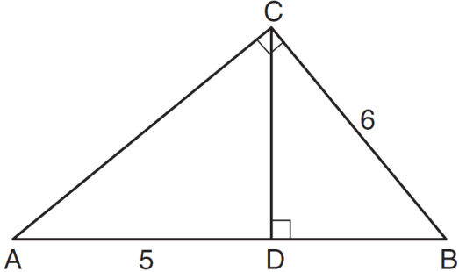

7) In the diagram below of right triangle ABC, altitude is drawn to hypotenuse , , and . What is the length of ?

