Name:____________________________________________ **Unit 7 Review #1**

Monica

Geometry Period:_____

Date:_______________________________________

**Directions:** Answer all of the questions below. If necessary, use your notes and previous handouts. All answers should be written in simplest form and if needed, round to the nearest tenth.

1) Scalene triangle *ABC* is similar to triangle *DEF*. Which statement is *false*?

|  |  |
| --- | --- |
| 1) |  |
| 2) |  |
| 3) |  |
| 4) |  |

2) If , , and , what is ?

3) If , and FR = 12, TF = 9, and SW = 12, what is the length of WX?

4) Given: 

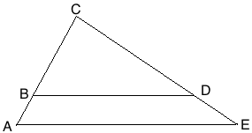

Prove: 

5) In the diagram below of right triangle *ACB*, altitude  intersects  at *D*. If  and ,find the length of  in simplest radical form.

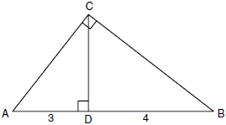

6) In the diagram below, the length of the legs  and  of right triangle *ABC* are 6 cm and 8 cm, respectively. Altitude  is drawn to the hypotenuse of . What is the length of  to the *nearest tenth of a centimeter*?

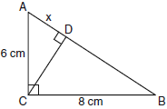

7) In the diagram of  shown below, . If , , and , what is the length of ?

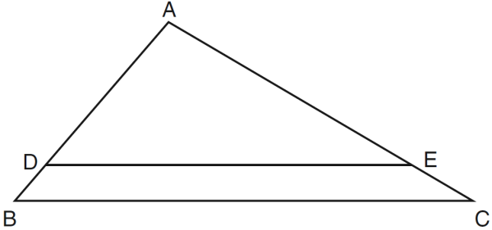

8) In  below, AD is the angle bisector of . If AB = 6, AC = 4, and BC = 8, what is the length of DC?

