Name:______________________________________ **Unit 7 Review #2**

Monica

Geometry Period:____

Date:_______________________________

**Directions: Answer all of the questions below. Be sure to show your work!**

1) The three lines in the diagram below are parallel. Determine the value of x.

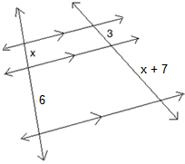

2) In , point *D* is on , and point *E* is on  such that . If , , and , what is the length of ?

3) In the diagram below of , *E* is a point on  and *B* is a point on , such that . If AE=3, ED = 6, andAC = 15, find the length of AB.

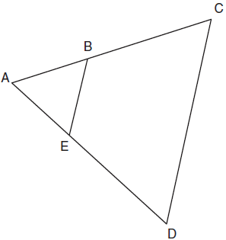

4) In the diagram below, . What additional piece of information is necessary to prove ? With this additional piece of information, what theorem or postulate would you use to prove the triangles are similar?

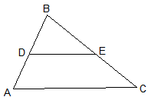

5) Look back at question 4. Answer the question again using a ***different*** piece of information.

6) In the diagram below, . If DB = 6, DE = x + 4, BC = 12, and AB = 16, what is the value of x?

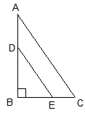

7) The accompanying diagram shows a 24-foot ladder leaning against a building. A steel brace extends from the ladder to the point where the building meets the ground. The brace forms a right angle with the ladder. If the steel brace is connected to the ladder at a point that is 10 feet from the foot of the ladder, what is the value of x? Write your answer in simplest radical form.

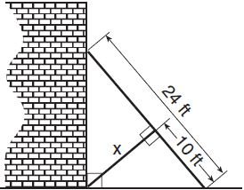

8) In the diagram below of right triangle *ACB*, altitude  is drawn to hypotenuse . If  and , what is the length of ?

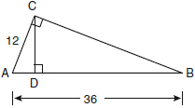

9) In ,  is a right angle and  is drawn perpendicular to hypotenuse . If , , and , what is the length of ?

10) In the diagram below, , , , and . Prove that .

