NAME:__________________________________________________

AREA FORMULAS FOR TWO-DIMENSIONAL FIGURES

SHAPE | AREA FORMULA
Circle  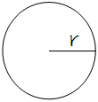 | Circumference =
Square

Rectangle

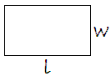

Triangle
