Name:__________________________________________ **Unit 8 – Transformation Notes**

Monica

Geometry Period:____

Date:_______________________________________

|  |  |
| --- | --- |
|  | **RULES OF TRANSFORMATIONS** |
| **REFLECTIONS** | If a point  is reflected over the **y – axis**, the new coordinates will be ______________. |
| ***Example:*** If (3, -4) is reflected over the y-axis, the new coordinates will be ______________. |
| If a point  is reflected over the **x –axis**, the new coordinates will be ____________. |
| ***Example:*** If (3, -4) is reflected over the x-axis, the new coordinates will be ______________. |
| If a point  is reflected over the line **y = x**, the new coordinates will be ____________. |
| ***Example:*** If (3, -4) is reflected over the line y = x, the new coordinates will be ______________. |
| If a point  is reflected over the line **y = -x**, the new coordinates will be ____________. |
| ***Example:*** If (3, -4) is reflected over the line y = -x, the new coordinates will be ______________. |
| **ROTATIONS** | If a point  is **rotated about the origin 90°**, the new coordinates will be ____________. |
| ***Example:*** If (3, -4) is rotated about the origin 90°, the new coordinates will be ______________. |
| If a point  is **rotated about the origin 180°**, the new coordinates will be ____________. |
| ***Example:*** If (3, -4) is rotated about the origin 180°, the new coordinates will be ______________. |
| If a point  is **rotated about the origin 270°**, the new coordinates will be ____________. |
| ***Example:*** If (3, -4) is rotated about the origin 270°, the new coordinates will be ______________. |
| **DILATIONS** | If a point  is **dilated about the origin by a scale factor of *k***, the new coordinates will be ___________. |
| ***Example:*** If (3, -4) is dilated about the origin by a scale factor of 2, the new coordinates will be _________. |

Put a check in each box to show what is preserved by each transformation.

|  |  |  |  |  |
| --- | --- | --- | --- | --- |
| **TRANSFORMATION** | **PRESERVES ORIENTATION** | **PRESERVES LENGTH** | **PRESERVES ANGLE MEASURES** | **PRESERVES SLOPE** |
| **Reflection** |  |  |  |  |
| **Rotation** |  |  |  |  |
| **Dilation** |  |  |  |  |

1) The coordinates of the vertices of  are , , and . State the coordinates of , the image of  after a rotation of 90° about the origin. [The use of the set of axes below is optional.]

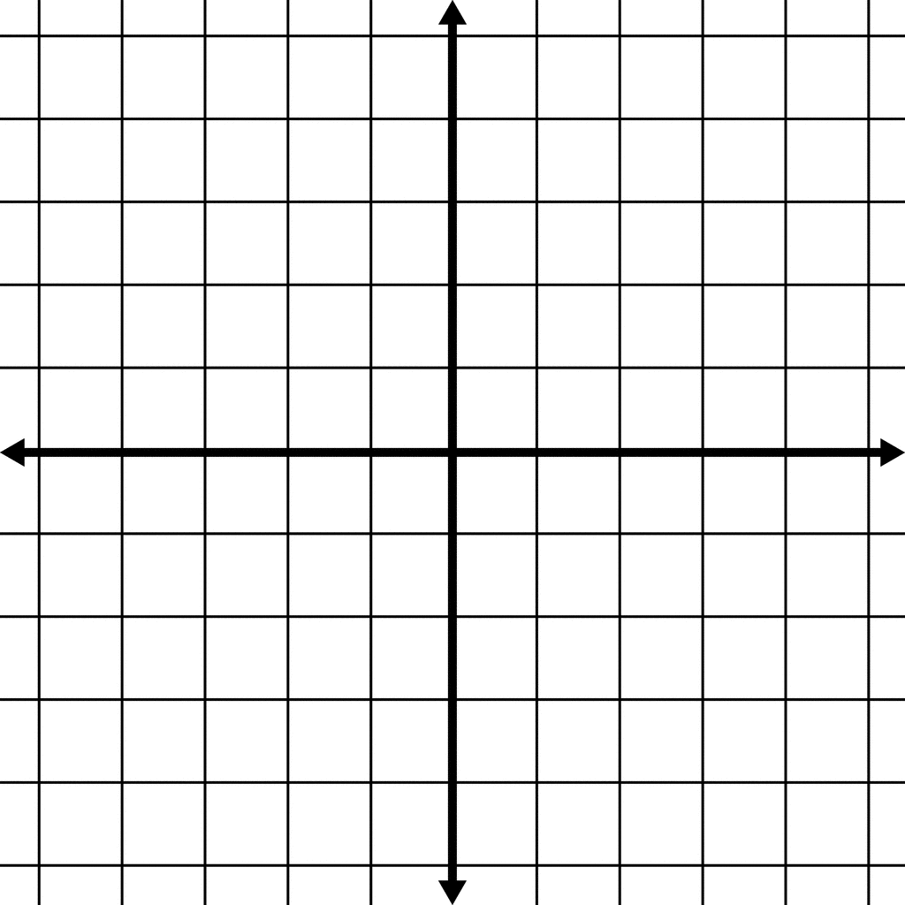

2) Triangle *SUN* has coordinates *S*(0,5), *U*(3,2), and *N*(3,0). On the accompanying grid, draw and label . Then, graph and state the coordinates of , the image of after a reflection in the *y*-axis.



3) Triangle *XYZ*, shown in the diagram below, is reflected over the line . State the coordinates of , the image of .

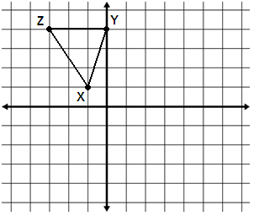

4) Triangle MJZhas coordinates M (-1,-2), *J*(0,1), and Z (2,2). On the accompanying grid, draw and label . Then, graph and state the coordinates of  , the image of after a dilation by a scale factor of 2.



5) As shown in the diagram below, square ABCD was transformed to create image A’B’C’D’. There are no coordinates to identify the points. What type of transformation must have taken place? Why?

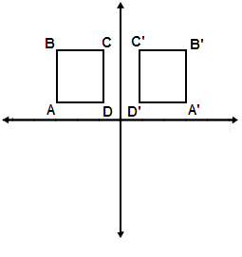

6) Point *A* is rotated 180° in a counterclockwise direction about the origin. If the coordinates of *A* are , what are the coordinates of *,* its image?

7) Point A’ is (3, -1) and is the result after reflecting point A over the line y = x. What are the coordinates of point A?

8) A transformation took place that preserved the length of the segments, but not the orientation. What type of transformation must have taken place?

9) Point A was reflected over the line y = x to create the image point A’. Then, point A’ was rotated 90° about the origin to create the new image point A’’. What single transformation could transform point A to point A’’?