Name:__________________________________________ **Unit 8 – Notation and Transformations**

Monica

Geometry Period:____

Date:__________________________________

**Directions:** Questions 1 - 5 are multiple choice Regents Questions. Select the best answer for each question. Questions 6 - # are open-ended Regents Questions. Read the questions carefully and show all necessary work.

1) What is the image of *A*(5,2) under ?

1) (-5,2) 2) (5, -2) 3) (2,5) 4) (-2,5)

2) What is the image of the point (2, -3) after the transformation ?

1) (2, 3) 2) (-2, -3) 3) (-2, 3) 4) (-3, 2)

3) What is the image of (5, -2) under the transformation ?

1) (-5, 2) 2) (5, 2) 3) (2, 5) 4) (-2, 5)

4) What is the image of the point (-5, 2) under the translation ?

1) (-9, 5) 2) (-8, 6) 3) (-2, -2) 4) (-15, -8)

5) If translation *T* maps point (-3, 1) onto point (5, 5), which is translation *T*?

1)  2)  3)  4) 

6) Triangle *TAP* has coordinates *T*(-1, 4), *A*(2, 4), and *P*(2, 0). On the set of axes below, graph and label , the image of  after the translation .

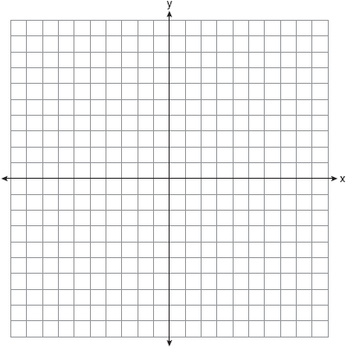

7) The coordinates of the vertices of  are *A*(1, 2), *B*(-4, 3), and *C*(-3, -5). Graph and state the coordinates of , the image of  after  about the origin.



8) The coordinates of the endpoints of  are *A*(0, 2) and *B*(4, 6). Graph and state the coordinates of  and, the images of *A* and *B* after the transformation .



9) The coordinates of the endpoints of  are *A*(-8, -4) and *B*(10, 6). Graph and state the coordinates of  and, the images of *A* and *B* after the transformation .

