Name:_________________________________________ **Unit 8 – Composition of Transformations**

Monica

Geometry Period:____

Date:______________________________

**Directions:** All of the questions below are Regents questions. Read each question carefully and answer the question being asked!

1) The coordinates of  are *J*(1, -2), *R*(-3, 6), and *B*(4,5). What are the coordinates of the vertices of its image after the transformation  ?

|  |  |
| --- | --- |
| 1) |  |
| 2) |  |
| 3) |  |
| 4) |  |

2) Which transformation is equivalent to the composite line reflections  ?

|  |  |  |
| --- | --- | --- |
|  | 1) | a rotation |
|  | 2) | a dilation |
|  | 3) | a translation |
|  | 4) | a glide reflection |

3) On the accompanying grid, graph and label  with vertices *A*(3,1), *B*(0,4) and *C*(-5,3). On the same grid, graph and label , the image of  after the transformation ?



4) Given:  with coordinates *A*(1, 2), *B*(0, 5), and *C*(5, 4).

*a* On the graph below, draw and label *.*

*b* Graph and state the coordinates of *,* the image of  after the translation  .

*c* Graph and state the coordinates of *,* the image of  after a reflection in the *x*-axis.

*d* Graph and state the coordinates of *,* the image of  after a reflection in the origin.

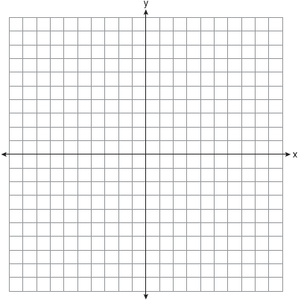

5) Triangle *ABC* has coordinates *A*(-1, 2), *B*(6, 2), and *C*(3, 4).

*a* On the grid below, draw and label *.*

*b* Graph and state the coordinates of *,* the image of  after the composition 

*c* Write a transformation equivalent to 

