Name:____________________________________________ Unit 8 – Composition of Transformations 2
Monica
Geometry Period:____
Date:_______________________________

Directions: All of the questions below are old Regents questions. Read each of the questions carefully and answer the question being asked. You must show all necessary work to receive a “MS” rating! Use a pencil to plot all points and figures, and use a ruler to connect the points!!!

1) Triangle ABC has coordinates , , and . Given the transformations T, U, and W described below:
T:
U:
W:
a. Graph and graph and state the coordinates of its image , after transformation T.
b. Graph and state the coordinates of , the image of after transformation U.
c. Graph and state the coordinates of , the image of after transformation W.
d. Which transformation, T, U, or W, is not an isometry? Why?
e. Which transformation, T, U, or W, does not preserve orientation?

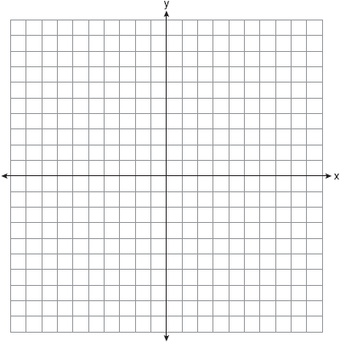

2) The coordinates of the vertices of are , , and .
a. On the graph below, draw and label .
b. Graph and state the coordinates of , the image of after a reflection over the line .
c. Graph and state the coordinates of , the image of after a reflection in the x-axis.
d. Graph and state the coordinates of , the image of after the transformation .

3) a. Graph and label the following equations, a and b, on the accompanying set of coordinate axes.
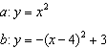
b. Describe the composition of transformations performed on a to get b.
4) a. On the accompanying grid, graph the equation in the interval and label it a.
b. On the same grid, sketch the image of a under and label it b.

5) A shape to be used in a computer game is placed on a Cartesian coordinate plane. The equation of the shape is . On the accompanying grid, graph the shape and label it a. In the game, the shape is moved under the composition . Draw this image, label it b, and state its equation.

6) On the graph below, draw and label , whose vertices are , , and . On the same set of axes, graph and state the coordinates of
a. , the image of after .
b. , the image of after .
c. , the image of after .
Based upon these graphs, write a single transformation that shows the composition .

