Unit 8 - Identifying and Analyzing Transformations
REGENTS MULTIPLE CHOICE QUESTIONS
DO NOT WRITE ON ME!!!
Answer questions on a separate piece of paper.
(Answers on last page.)

1) A polygon is transformed according to the rule: . Every point of the polygon moves two units in which direction?
1) up 2) down 3) left 4) right

2) Which transformation is an example of an opposite isometry?
1)
2)
3)
4)

3) Which transformation represents a dilation?
1)
2)
3)
4)

4) Which type of transformation is ?
1) | dilation
2) | reflection
3) | rotation
4) | translation

5) The coordinates of any point after a reflection in the x-axis can always be represented by
1)
2)
3)
4)

6) Which transformation is not an isometry?
1)
2)
3) | 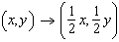
4)

7) Under the transformation , which property is not preserved?
1) | distance
2) | orientation
3) | parallelism
4) | angle measure

8) In the accompanying graph, if point P has coordinates , which point has coordinates ?
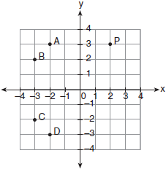
1) | A
2) | B
3) | C
4) | D

9) The graph below shows and its image, , after a transformation. Which transformation would map onto ?
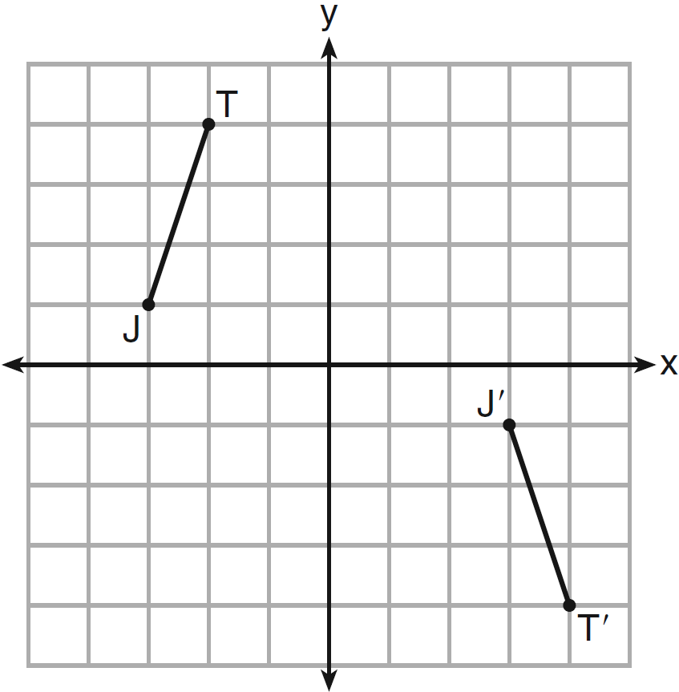
1) | translation
2) | glide reflection
3) | rotation centered at the origin
4) | reflection through the origin

10) As shown on the graph below, is the image of under a single transformation. Which transformation does this graph represent?
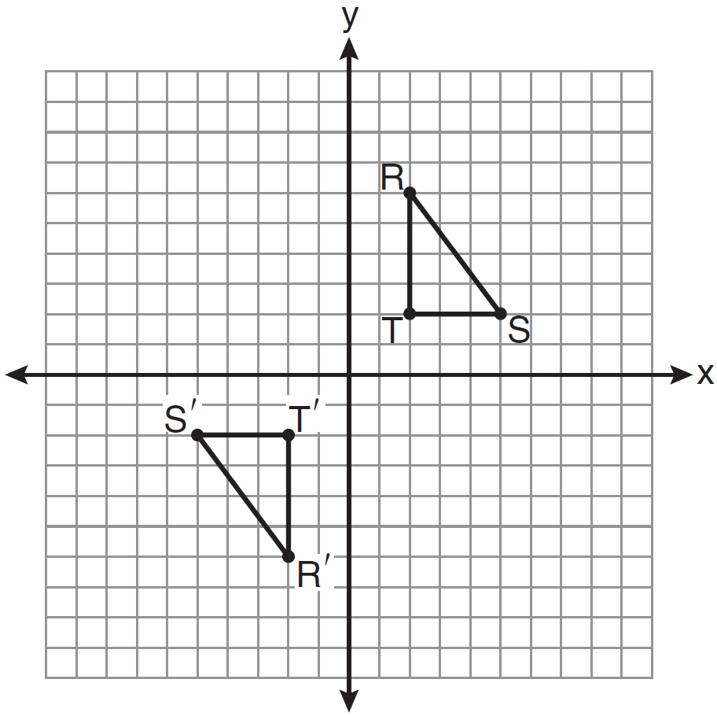
1) | glide reflection
2) | line reflection
3) | rotation
4) | translation

11) The diagram below shows and . Which transformation will move onto such that point D is the image of point A and point E is the image of point B?
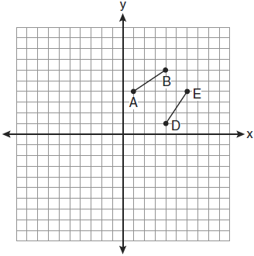
1)
2)
3)
4)

12) Which transformation is not always an isometry?
1) | rotation
2) | dilation
3) | reflection
4) | translation

13) In the diagram below, which transformation was used to map to ?
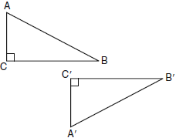
1) | dilation
2) | rotation
3) | reflection
4) | glide reflection

14) In the accompanying diagram, which transformation changes the solid-line parabola to the dotted-line parabola?
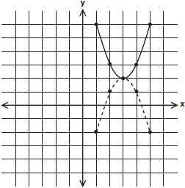

1) | translation
2) | line reflection, only
3) | rotation, only
4) | line reflection or rotation

15) Which transformation is an opposite isometry?
1) dilation 2) line reflection 3) rotation of 90° 4) translation
16) Which transformation is a direct isometry?
1)
2)
3)
4)

- 4
- 3
- 4
- 4
- 3
- 3
- 1
- 2
- 2
- 3
- 4
- 2
- 4
- 4
- 2
- 4

