Name:____________________________________ **Unit 8 – Line of Reflection**

Monica

Geometry Period:_____

Date:____________________________________

1) In the diagram below, was reflected over the y-axis to create image . Use this diagram to answer the questions below.

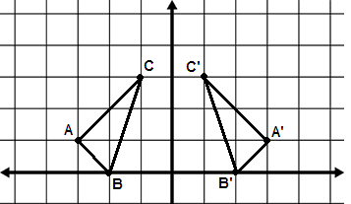

a) Identify the coordinates of the points:

A:__________ B:__________ C:__________ A’:__________ B’:__________ C’:__________

b) Identify the slope of the y-axis:_______________________.

c) Determine the slopes of the following segments:

Slope of = Slope of= Slope of =

d) Determine the midpoints of the following segments:

Midpoint of = Midpoint of= Midpoint of =

e) On which line did the midpoints of each of the segments land? What role does this line serve?

f) How do the slopes of , , and relate to the slope of the y-axis?

g) What does the relationship of the slopes and the coordinates of the midpoints tell you about the line of reflection for a given image?

2) In the diagram below, was reflected over the line y = x to create image. In part 1g, you should have determined that the line of reflection will be the perpendicular bisector of the segment connecting a point and its image. Demonstrate this will also be true in the example below by showing that the midpoint of lands on y = x and that the slope of  is perpendicular to the slope of y = x.

