Name:_____________________________________________ Unit 8 Review
Monica
Geometry Period:____
Date:________________________________

Directions: Questions 1 – 10 are multiple choice. Choose the best answer for each question. For questions 11 – 15, read the question carefully and be sure to answer the question being asked!

1) What are the coordinates of , the image of , after a counterclockwise rotation of 90º about the origin?

1) (-2, 4) 2) (-2, -4) 3) (-4, 2) 4) (-4, -2)

2) What are the coordinates of point after it is reflected over the x-axis?

- (2,3) 2) (-2, 3) 3) (-2, -3) 4) (-3, 2)

3) A translation moves to . What are the coordinates of the image of point under the same translation?
1) (0, -9) 2) (-5, -3) 3) (-6, -1) 4) (-6, -9)

4) What are the coordinates of point under dilation ?

1) (-2, 8) 2) (2, -8) 3) (-8, 2) 4) (8, -2)

5) What is the image of point after the composition of transformations defined by ?

1) (-4, 2) 2) (4, -2) 3) (-4, -2) 4) (2, -4)

6) A transformation of a polygon that always preserves both length and orientation is

1) Dilation 2) Translation 3) Line reflection 4) Glide reflection

7) The vertices of parallelogram ABCD are , , , and . If ABCD is reflected over the x-axis, how many vertices remain invariant?

1) 1 2) 2 3) 3 4) 0

8) Which transformation is not always an isometry?

1) Rotation 2) Translation 3) Reflection 4) Dilation

9) The rectangle ABCD shown in the diagram below will be reflected across the x-axis. What will not be preserved?
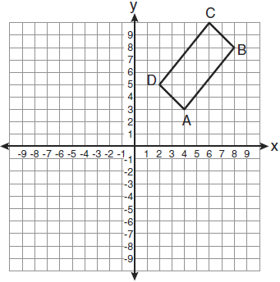

1) | slope of
2) | parallelism of and
3) | length of
4) | measure of

10) Which type of transformation is illustrated in the accompanying diagram?
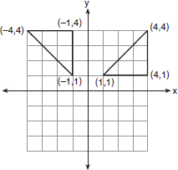

1) | dilation
2) | reflection
3) | translation
4) | rotation

11) On the coordinate plane below, graph the equation . Graph the image of this equation under the transformation . Write the equation of this graph.

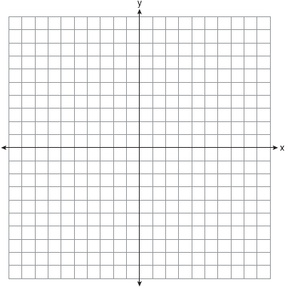
12) The coordinates of the vertices of , and . On the grid below, graph and label , the result of the composite transformation . State the coordinates of , , and . Is this an isometry? Why or why not?

13) On the accompanying set of axes, draw , whose coordinates are , and . Then draw, label, and state the coordinates of , the image of after the transformation that maps to . Based on your diagram, identify the type of transformation that was performed.
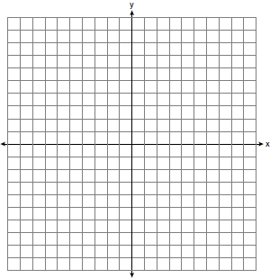

CHALLENGE: Design your own transformation question! It could earn you an ES!

