Name:_____________________________________ Unit 9 – More Volume
Monica
Geometry Period:____
Date:________________________________

Directions: Answer all of the questions below. Be sure to show all of your work!

1) A regular pyramid with a square base is shown in the diagram below. A side, s, of the base of the pyramid is 12 meters, and the height, h, is 42 meters. What is the volume of the pyramid in cubic meters?
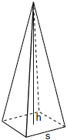

2) The base of a pyramid is a rectangle with a width of 6 cm and a length of 8 cm. Find, in centimeters, the height of the pyramid if the volume is .

3) What is the volume, in cubic centimeters, of a cylinder that has a height of 15 cm and a diameter of 12 cm?

4) A right circular cylinder has a volume of 1,000 cubic inches and a height of 8 inches. What is the radius of the cylinder to the nearest tenth of an inch?

5) In the diagram below, a right circular cone has a diameter of 8 inches and a height of 12 inches. What is the volume of the cone to the nearest cubic inch?
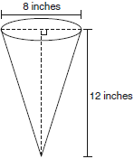

6) The diameter of a sphere is 15 inches. What is the volume of the sphere, to the nearest tenth of a cubic inch?

7) The radius of a cylinder is 4 inches and the height is 9 inches. If a cone has the same volume as the cylinder, but has a height of 12 inches, what is the length of the radius of the cone?

8) If the volume of a sphere is cubic inches, what is the length of the diameter of the sphere?

