Name:________________________________ Unit 9 – Surface Area and Lateral Area
Monica
Geometry Period:____
Date:__________________________

Directions: Answer all of the questions below. You must show all of your work to receive a “MS” rating.

1) The cylindrical tank shown in the diagram below is to be painted. The tank is open at the top, and the bottom does not need to be painted. Only the outside needs to be painted. Each can of paint covers 600 square feet. How many cans of paint must be purchased to complete the job?
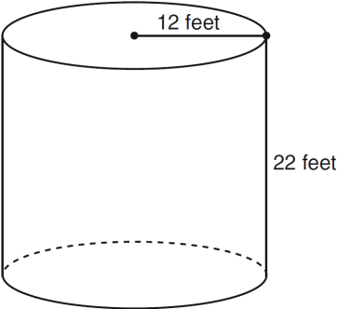

2) A paint can is in the shape of a right circular cylinder. The volume of the paint can is 600 cubic inches and its altitude is 12 inches. Find the radius, in inches, of the base of the paint can. Express the answer in simplest radical form. Find, to the nearest tenth of a square inch, the lateral area of the paint can.

3) A right circular cone has a base with a radius of 15 cm, a vertical height of 20 cm, and a slant height of 25 cm. Find, in terms of , the number of square centimeters in the lateral area of the cone.

4) If the volume of a sphere is represented by cubic inches, what is the surface area in terms of ?

5) If a cylinder has a radius of 9 inches and a height of 6 inches, and a cone has the same height as the cylinder, what would the radius of the cone have to be in order to make the cylinder and cone have equal volumes? Write your answer in simplest radical form.

6) What does the length of the diameter need to be in a sphere in order for the surface area and volume to be equal?

7) The radius and vertical height of a cone is 5 inches and 12 inches, respectively. What is the lateral area of the cone?

