Names:____________________________________________________________ **Triangles**

Monica

Geometry Periods:_____

Date:________________________

**Step 1:** The figures below are similar. Determine the similarity ratio for each pair of figures. (Make sure it’s in simplest form.)

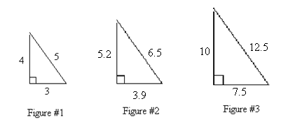

|  |  |
| --- | --- |
| **Figures** | **Similarity Ratio** |
| **Figure #1: Figure #2** |  |
| **Figure #2: Figure #3** |  |
| **Figure #1: Figure #3** |  |

**Step 2:** Using the provided formulas, determine the perimeter and area of each triangle.

Perimeter = Add up all three sides Area = 

|  |  |  |
| --- | --- | --- |
|  | **Perimeter** | **Area** |
| #1 |  |  |
| #2 |  |  |
| #3 |  |  |

**Step 3:** Write the ratios for the information provided below. Write the ratios in simplest form.

|  |  |  |  |
| --- | --- | --- | --- |
|  | **Similarity Ratio of Figures** | **Ratio of perimeters** | **Ratio of Areas** |
| Figure #1: Figure #2 |  |  |  |
| Figure #1: Figure #3 |  |  |  |
| Figure #2: Figure #3 |  |  |  |