Name:____________________________________________ **Unit 9 Review**

Monica

Geometry Period:_____

Date:_______________________________________

**Directions:** Answer all of the questions below. If necessary, use your notes and previous handouts. All answers should be written in simplest form and if needed, round to the nearest tenth. These questions are excellent preparation for your Unit 9 Test. When you’re done, you can check your answers online at geometry2014.weebly.com under “Unit 9 – Similarity”.

1) Scalene triangle *ABC* is similar to triangle *DEF*. Which statement is *false*?

|  |  |
| --- | --- |
| 1) |  |
| 2) |  |
| 3) |  |
| 4) |  |

2) If , , and , what is ?

3) If , and FR = 12, TF = 9, and SW = 12, what is the length of WX?

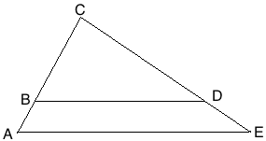

4) Given: 

Prove: 

5) In the diagram below of right triangle *ACB*, altitude  intersects  at *D*. If  and ,find the length of  in simplest radical form.

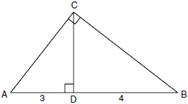

6) In the diagram below, the length of the legs  and  of right triangle *ABC* are 6 cm and 8 cm, respectively. Altitude  is drawn to the hypotenuse of . What is the length of  to the *nearest tenth of a centimeter*?

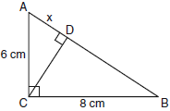

7) In the diagram of  shown below, . If , , and , what is the length of ?

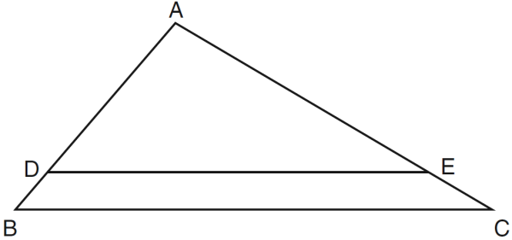

8) In  below, AD is the angle bisector of . If AB = 6, AC = 4, and BC = 8, what is the length of DC?

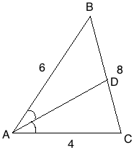

9) In , point *D* is on , and point *E* is on  such that . If , , and , what is the length of ?

10) In the diagram below of , *E* is a point on  and *B* is a point on , such that . If AE=3, ED = 6, andAC = 15, find the length of AB.

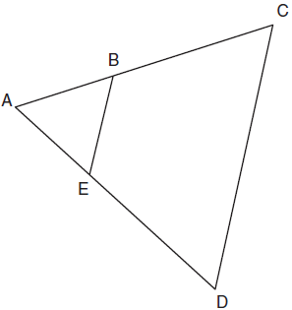

11) In the diagram below, . If DB = 6, DE = x + 4, BC = 12, and AB = 16, what is the value of x?

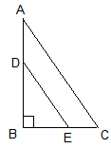

12) In the diagram below of right triangle *ACB*, altitude  is drawn to hypotenuse . If  and , what is the length of ?

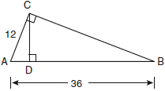

13) In ,  is a right angle and  is drawn perpendicular to hypotenuse . If , , and , what is the length of ?

14) In the diagram below, , , , and . Prove that .

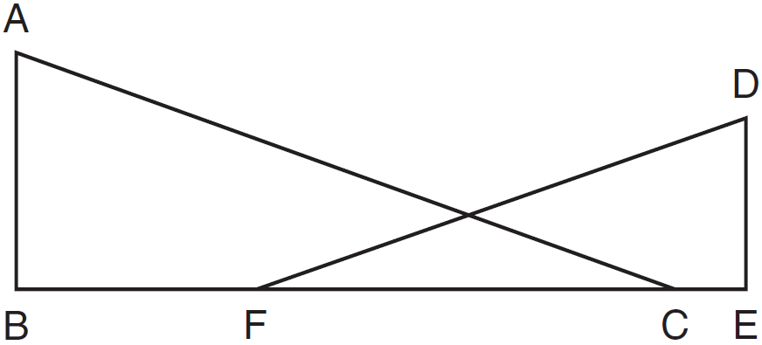

15)

Given:



Prove: 

